Working with Webdriver:
<?xml version="1.0" encoding="UTF-8"?>
<project xmlns="http://maven.apache.org/POM/4.0.0"
xmlns:xsi="http://www.w3.org/2001/XMLSchema-instance"
xsi:schemaLocation="http://maven.apache.org/POM/4.0.0 http://maven.apache.org/xsd/maven-4.0.0.xsd">
<modelVersion>4.0.0</modelVersion>

<groupId>org.mytestthree</groupId>
<artifactId>SampleDemoTwo</artifactId>
<version>1.0-SNAPSHOT</version>

<properties>
<maven.compiler.source>17</maven.compiler.source>
<maven.compiler.target>17</maven.compiler.target>
<project.build.sourceEncoding>UTF-8</project.build.sourceEncoding>
</properties>
<dependencies>
<!-- https://mvnrepository.com/artifact/org.seleniumhq.selenium/selenium-java -->
<!-- https://mvnrepository.com/artifact/org.seleniumhq.selenium/selenium-java -->
<dependency>
<groupId>org.seleniumhq.selenium</groupId>
<artifactId>selenium-java</artifactId>
<version>4.21.0</version>
</dependency>
<!-- https://mvnrepository.com/artifact/io.github.bonigarcia/webdrivermanager -->
<!-- https://mvnrepository.com/artifact/io.github.bonigarcia/webdrivermanager -->
<dependency>
<groupId>io.github.bonigarcia</groupId>
<artifactId>webdrivermanager</artifactId>
<version>5.6.2</version>
</dependency>

<dependency>
<groupId>org.slf4j</groupId>
<artifactId>slf4j-simple</artifactId>
<version>2.0.16</version>
<scope>test</scope>
</dependency>

Script:
import io.github.bonigarcia.wdm.WebDriverManager;
import org.openqa.selenium.WebDriver;
import org.openqa.selenium.chrome.ChromeDriver;
import org.openqa.selenium.firefox.FirefoxDriver;

public class LaunchUrl {
public static void main(String[] args) {
WebDriverManager.chromedriver().setup();
WebDriver driver = new ChromeDriver();
driver.get("https://www.jetbrains.com/idea/");

}
}

https://online.actitime.com/gmukti/login.do

Automation Demo Site

driver.findElement(By.xpath("//*[text()='Submit']"))

driver.findElement(By.xpath("//*[@name='password']"));
By TagName:
driver.findElement(By.xpath("//p"));

driver.findElement(By.xpath("//*[contains(@href,'google.com')]"));

driver.findElement(By.xpath("//*[starts-with(@id,'user')]"));
driver.findElement(By.xpath("//*[ends-with(@id,'name')]"));
Selenium Components: Selenium IDE, Selenium RC, Selenium WebDriver and Selenium Grid

Selenium IDE: Integrated Development Environment
It an an add in/ Plugin in Chrome, Firefox, IE
It is Record and Playback Tool:

Selenese Commands
WebElements: The elements which are located on the webPage
Locators are descriptions used to locate the WebElements

XPATH: //Tag[@attribute=’value’]
CSS: Tag[attribute=’value’]

assertTitle: Checks if the passed title matches with the actual title of the webpage and will not move to the next line of test code.
verifyTitle: Checks if the passed title matches with the actual title of the webpage and will move to the next line of the test code.

Non functional Testing Tools: Load Runner and JMeter
SonarQube and JMeter

Selenium RC(Remote Control) was used for Programming purpose.
Selenium is a client - Server Architecture.
It has less number of APIs(Weaker APIs).
Selenium RC is not used much because of client - Server Architecture.
Most of the times the server will not start.
Selenium WebDriver: It has Stronger API.
It is only client Architecture.

Abhishek Gupta
- Create a new project by either closing every project or either you can click on top left corner three lines are present click on that than on file create a new project.
- In the left side bar search where Maven Archetype is written click on that then give a name to the project. On the location select the desired location where you want to save your project.
- Then down there is a field where you can search for the dependency and type quickstart you will get a dependency. Select it and then create a new project with the specifications.
- Now give some time to get the dependency added in the project afterwards click on the pom.xml file(it is present in project structure) and then copy and paste this dependency over there as the way junit dependency is added.
Required dependency
<dependency>
<groupId>org.seleniumhq.selenium</groupId>
<artifactId>selenium-java</artifactId>
<version>4.24.0</version>
</dependency>
- You will see Maven refresh button is there click on it and then it will add this new dependency then go to src folder inside that you will find a folder named as Java click on that create a new package inside the folder and create a java file inside it now please write this code :

import org.openqa.selenium.WebDriver;
import org.openqa.selenium.chrome.ChromeDriver;
public class Main01 {
public static void main(String[] args) {
WebDriver driver=new ChromeDriver();
driver.get("https://opensource-demo.orangehrmlive.com/web/index.php/auth/login");
}
}

Locators Used:
- Id
- Name
- linkText
- PartiallinkText
- Xpath
- CSS Selector

Harsh Shende
package com.interviewprep;

import org.openqa.selenium.By;
import org.openqa.selenium.WebDriver;
import org.openqa.selenium.chrome.ChromeDriver;

public class App {
public static void main(String[] args) {
//Creating an Object of ChromeDriver class
WebDriver webDriver01=new ChromeDriver();
//Visits to mentioned URL
webDriver01.get("https://www.rediff.com/");

//Visiting to Sign-in page referring to anchor tag and will update the webpage
webDriver01.findElement(By.linkText("Sign in")).click();
//Extracting the username field and entering data
webDriver01.findElement(By.id("login1")).sendKeys("sampleUsername");
//Extracting the password field and entering data
webDriver01.findElement(By.id("password")).sendKeys("samplePassword");
//Extracting the button field and clicking on button
webDriver01.findElement(By.name("proceed")).click();

}

Locators are those which are used to locate the webElements on the webpage

- Id
- Name
- linkText
- partiallinkText
- Xpath
- CSS

}By.

public class Application {
public static void main(String[] args) throws InterruptedException {
WebDriver driver = new ChromeDriver();
// WebDriver driver = new FirefoxDriver();
driver.get("https://www.rediff.com/");
// Thread.sleep(20);

// driver.findElement(By.linkText("Sign in")).click();
driver.findElement(By.partialLinkText("Sign")).click();
//Extracting the username & password field and entering data
driver.findElement(By.id("login1")).sendKeys("sampleUsername");
driver.findElement(By.id("password")).sendKeys("samplePassword");

//Extracting the button field and clicking on button
driver.findElement(By.name("proceed")).click();
}
}

Xpath
package org.example;

import org.openqa.selenium.By;
import org.openqa.selenium.WebDriver;
import org.openqa.selenium.chrome.ChromeDriver;
import org.openqa.selenium.firefox.FirefoxDriver;

/**
* Hello world!
*
*/
public class App
{
public static void main(String[] args) throws InterruptedException {
WebDriver driver = new ChromeDriver();
// WebDriver driver = new FirefoxDriver();
driver.get("https://www.rediff.com/");
// Thread.sleep(2);

// driver.findElement(By.linkText("Sign in")).click();
driver.findElement(By.partialLinkText("Sign")).click();
//Extracting the username & password field and entering data
// driver.findElement(By.id("login1")).sendKeys("sampleUsername");

driver.findElement(By.xpath("//input[@type='text']")).sendKeys("sampleUsername");
driver.findElement(By.id("password")).sendKeys("samplePassword");

//Extracting the button field and clicking on button
driver.findElement(By.name("proceed")).click();
}
}

getText() Method

WebElement var1 = driver.findElement(By.linkText("Forgot Password?"));
String actual_text= var1.getText( );
System.out.println(actual_text);

package org.example;

import org.openqa.selenium.By;
import org.openqa.selenium.WebDriver;
import org.openqa.selenium.WebElement;
import org.openqa.selenium.chrome.ChromeDriver;

public class App
{
static String expected_text="Forgot Password?";
public static void main( String[] args ) throws InterruptedException {

WebDriver driver = new ChromeDriver();
driver.get("https://www.rediff.com/");
//button[@type="submit"]
// Thread.sleep(20);
//By link text
// driver.findElement(By.linkText("rediff.com")).click();

//By partial link text
driver.findElement(By.partialLinkText("Sign")).click();

//Entering the username for login by using id
// driver.findElement(By.id("login1")).sendKeys("barun");

//Entering the username for login by relative Xpath by using
driver.findElement(By.xpath("//input[@name=\"login\"]")).sendKeys("barun");

//Entering the password for login by using id locator
driver.findElement(By.id("password")).sendKeys("admin");

WebElement var1 = driver.findElement(By.linkText("Forgot Password?"));
String actual_text= var1.getText();
System.out.println(actual_text);
if(actual_text.equals(expected_text))
{
System.out.println("Expected text "+ expected_text +" is present and matches the actual text.So passed");
}else{
System.out.println("Expected text "+ expected_text +" is not present and does not match the actual text.So failed");
}

}
}

Drop-downs

Select class to work with drop down
WebDriver driver = new ChromeDriver();
driver.get("https://formstone.it/components/dropdown/demo/");

WebElement var1 = driver.findElement(By.name("demo_multiple"));
Select selectObj = new Select(var1);
// selectObj.selectByValue("4");

// selectObj.selectByVisibleText("Four");

selectObj.selectByIndex(3);

Action Class: Helps us to work with mouse hover and Keyboard actions

Code for Implementation:
public static void main(String[] args) throws InterruptedException{
WebDriver driver = new ChromeDriver();
driver.get("https://www.naukri.com/");

WebElement element = driver.findElement(By.xpath("//div[text()='Companies']"));
Actions actionObj = new Actions(driver);

actionObj.moveToElement(element).perform();

Thread.sleep(50);
driver.findElement(By.xpath("//div[text()='Top companies']")).click();

Thread.sleep(50);

}

import org.openqa.selenium.By;
import org.openqa.selenium.JavascriptExecutor;
import org.openqa.selenium.WebDriver;
import org.openqa.selenium.WebElement;
import org.openqa.selenium.chrome.ChromeDriver;
import org.openqa.selenium.support.ui.ExpectedConditions;
import org.openqa.selenium.support.ui.WebDriverWait;

import org.openqa.selenium.By;
import org.openqa.selenium.WebDriver;
import org.openqa.selenium.WebElement;
import org.openqa.selenium.chrome.ChromeDriver;

public class FirstSelenium {
public static void main(String[] args) throws InterruptedException {
// Set up WebDriver
WebDriver driver = new ChromeDriver();
driver.get("https://formstone.it/components/dropdown/demo/");
JavascriptExecutor js = (JavascriptExecutor) driver;

// Scroll down to ensure content loads
js.executeScript("window.scrollBy(0,800)");

// Locate the dropdown element and click it to open the options
//WebElement dropdown = driver.findElement(By.xpath("//button[@class='fs-dropdown-item']"));
// dropdown.click();
Thread.sleep(10);
// Wait and select the option "Six" from the dropdown
WebElement optionSix = driver.findElement(By.xpath("//*[@id=\"demo_multiple-dropdown\"]/div/div[2]/button[4]"));
optionSix.click();

// Close the browser
//driver.quit();
}
}

Xpath-
Absolute XPath:

/html/body/div/div/div/div[4]/div[2]/form/fieldset/div/div/div[2]/button[3]

Relative Xpath

//*[@id="demo_multiple-dropdown"]/div/div[2]/button[2]
//tag[@attribute=’value’]->1—--Syntax
//input[@name=’username’]
//*[@tag=’value’]->2—Syntax

<input id =”input”........
Here input is the tag
Id is the attribute
And “input”
Is the value of the attribute

Vedant Asija

package org.example;

import org.openqa.selenium.By;
import org.openqa.selenium.WebDriver;
import org.openqa.selenium.WebElement;
import org.openqa.selenium.chrome.ChromeDriver;
import org.openqa.selenium.interactions.Actions;

public class test {
public static void main(String[] args) throws InterruptedException {
WebDriver driver = new ChromeDriver();
driver.get("https://demoqa.com/buttons");

// Maximise the screen
driver.manage().window().maximize();

Actions actionObj = new Actions(driver);

// single click
WebElement element1 = driver.findElement(By.xpath("//button[text()='Click Me']"));
Thread.sleep(50);
actionObj.click(element1).perform();

// Double click
WebElement douleClickElement = driver.findElement(By.id("doubleClickBtn"));
Thread.sleep(50);
actionObj.doubleClick(douleClickElement).perform();

// Right click
WebElement rightClickElement = driver.findElement(By.id("rightClickBtn"));
Thread.sleep(50);
actionObj.contextClick(rightClickElement).perform();
}
}

Vedant Asija

package org.example;

import org.openqa.selenium.By;
import org.openqa.selenium.WebDriver;
import org.openqa.selenium.WebElement;
import org.openqa.selenium.chrome.ChromeDriver;
import org.openqa.selenium.interactions.Actions;

public class DragAndDrop {
public static void main(String[] args) {
WebDriver driver = new ChromeDriver();

driver.get("https://demoqa.com/droppable");

Actions actionObj = new Actions(driver);

// element that is to be dropped
WebElement element1 = driver.findElement(By.id("draggable"));

// element where it is to be dropped
WebElement element2 = driver.findElement(By.id("droppable"));

// drop here text for that div will be printed
String str1 = element2.getText();

System.out.println(str1);

// from - to (place element in this manner)
actionObj.dragAndDrop(element1, element2).perform(); // always write perform method

// once it is dropped, text will be changed to Dropped
String str2 = element2.getText();

System.out.println(str2);
}
}

Working with Alerts

Alert pop-ups are implemented by using JavaScript language,
An alert is a specific type of message box generated by the browser using JavaScript's alert(), confirm(), or prompt() methods.

Alert box: Displays a simple message with an OK button (alert()).
Confirmation box: Allows the user to accept or cancel an action (confirm()).
Prompt box: Collects user input with a text field (prompt()).

Alert will have Ok button, Cancel Button and a text on it.

use ctrl+shift+i or function+f12 for inspect
select button using arro

Code Implementation:
package com.testing;

import org.openqa.selenium.Alert;
import org.openqa.selenium.By;
import org.openqa.selenium.WebDriver;
import org.openqa.selenium.WebElement;
import org.openqa.selenium.chrome.ChromeDriver;
import org.openqa.selenium.interactions.Actions;

public class NewClass {
public static void main(String[] args) {
WebDriver driver = new ChromeDriver();
driver.get("https://retail.onlinesbi.sbi/retail/login.htm#");

driver.findElement(By.linkText("CONTINUE TO LOGIN")).click();

driver.findElement(By.id("Button2")).click();

Alert alertObj = driver.switchTo().alert();
String var1 = alertObj.getText();
System.out.println(var1);

alertObj.accept();
// for clicking on cancel button
alertObj.dismiss();
// Actions actionObj = new Actions(driver);
// actionObj.click(element);

// It clicked recognizing

}
}

78989983AA2DA41B2F35762E6E5642D5 | 94715BF51B9AD49033627D830AB5C06D

IItr

A popup is a window or dialog that appears on the screen and is usually created by the developer using HTML, CSS, and JavaScript.
For browser window popups, Selenium requires switching between windows using driver.getWindowHandles() and driver.switchTo().window()

For Dealing With Another Window and Pop-Ups
package org.example;

import org.openqa.selenium.By;
import org.openqa.selenium.WebDriver;
import org.openqa.selenium.WebElement;
import org.openqa.selenium.chrome.ChromeDriver;
import org.openqa.selenium.interactions.Actions;
import org.openqa.selenium.support.ui.Select;

import java.util.Iterator;
fn+F12 or ctrl+shift+i
import java.util.Set;

public class FlipkartAssignment {
public static void main(String[] args) {
WebDriver driver = new ChromeDriver();
driver.get("https://retail.onlinesbi.sbi/retail/login.htm#");

driver.findElement(By.linkText("CONTINUE TO LOGIN")).click();

driver.findElement(By.xpath("//*[text()='Forgot Username / Login Password ']")).click();

// Working till here

Set<String> handle = driver.getWindowHandles();
for(String values: handle)
System.out.println(values);

Iterator<String> iterator = handle.iterator();

String parentId = iterator.next();
System.out.println("This is the parent id: " + parentId);
String childId = iterator.next();
System.out.println("This is the child id: " + childId);

driver.switchTo().window(childId);

WebElement element = driver.findElement(By.xpath("//select[@name='issueCode']"));
Select selectObj = new Select(element);
selectObj.selectByVisibleText("Forgot Username");

driver.close();

}
}

//a[starts-with(text(),'Forgot Username')]
//a[contains(text(),'Forgot Username')

//AUTOMATED SIGNUP AND SIGNIN LOGIN
package com.kamiharsh;

import org.openqa.selenium.By;
import org.openqa.selenium.WebDriver;
import org.openqa.selenium.WebElement;
import org.openqa.selenium.chrome.ChromeDriver;
import org.openqa.selenium.edge.EdgeDriver;
import org.openqa.selenium.firefox.FirefoxDriver;

public class BonVoyage {
//Static Final Variables
final static String name="Kami Harsh";
final static String email="kami.harsh01@gmail.com";
final static String phone="1234567890";
final static String password="Harsh@123";
final static String address="New Zealand";

public static void main(String[] args) throws InterruptedException {
//Creating an Object of ChromeDriver class
WebDriver webDriver01=new ChromeDriver();

//Visits to mentioned URL
webDriver01.get("http://localhost:3001/");
Thread.sleep(200);
webDriver01.manage().window().maximize();
Thread.sleep(200);

//Extracting WebElements
webDriver01.findElement(By.xpath("//*[@id=\"root\"]/div[1]/div/header/div/div[2]/div/button")).click();
Thread.sleep(200);
webDriver01.findElement(By.xpath("//*[@id=\"root\"]/main/div/div/div[2]/div/form/div[3]/div[2]/a")).click();
Thread.sleep(200);
WebElement nameTextField=webDriver01.findElement(By.xpath("//*[@id=\":r1:\"]"));
nameTextField.sendKeys(name);
Thread.sleep(200);
WebElement emailTextField=webDriver01.findElement(By.xpath("//*[@id=\":r3:\"]"));
emailTextField.sendKeys(email);
Thread.sleep(200);
WebElement phoneTextField=webDriver01.findElement(By.xpath("//*[@id=\":r5:\"]"));
phoneTextField.sendKeys(phone);
Thread.sleep(200);
WebElement passwordTextField=webDriver01.findElement(By.xpath("//*[@id=\":r7:\"]"));
passwordTextField.sendKeys(password);
Thread.sleep(200);
WebElement confirmPasswordTextField=webDriver01.findElement(By.xpath("//*[@id=\":r9:\"]"));
confirmPasswordTextField.sendKeys(password);
Thread.sleep(200);
WebElement addressTextField=webDriver01.findElement(By.xpath("//*[@id=\":rb:\"]"));
addressTextField.sendKeys(address);
Thread.sleep(200);
webDriver01.findElement(By.xpath("/html/body/div/main/div/div/div[2]/div/form/button")).click();
Thread.sleep(1000);

emailTextField=webDriver01.findElement(By.id("email"));
emailTextField.sendKeys(email);
Thread.sleep(200);
passwordTextField=webDriver01.findElement(By.id("password"));
passwordTextField.sendKeys(password);
Thread.sleep(200);
webDriver01.findElement(By.xpath("/html/body/div/main/div/div/div[2]/div/form/button")).click();
Thread.sleep(200);
}
}

Synchronization: There are certain wait commands which help us to achieve Synchronization.

Thread.sleep: Is not preferable in the project.

Implicit wait
driver.manage().timeouts().implicitlyWait(10, TimeUnit.SECONDS);
Implicit wait is a global wait
Once defined it is applicable throughout the code for that instance of driver.
Explicit wait

WebDriverWait wait = new WebDriverWait(driver,30);
wait.until(ExpectedConditions.visibilityOfElementLocated(By.xpath("//div[contains(text(),'COMPOSE')]")))
Synchronization
Thread.sleep
Implicit wait
Explicit wait
Fluent wait

WebDriverWait ewait=new WebDriverWait(driver,60);
ewait.until(ExpectedConditions.presenceOfAllElementsLocatedBy(By.xpa
th(&quot;//div[text()=&#39;Compose&#39;]&quot;)));

Unlike Implicit waits, which apply globally, explicit waits are applied only to specific elements or conditions, making them more flexible and precise.

WebDriverWait wait = new WebDriverWait(driver,30);
wait.until(ExpectedConditions.visibilityOfElementLocated(By.xpath("//div[contains(text(),'COMPOSE')]")));

An implicit wait applies globally across the entire webdriver instance.This means that every element lookup will wait for the specified maximum amount of time before throwing NoSuchElementException if the element is not found.

Implicit wait waits only for the presence of elements in the DOM. It does not account for conditions like visibility, clickable or not

Explicit wait applies only to specific elements and conditions. It checks for specific conditions like clickable, visibility along with the appearance in the DOM. Once satisfied it moves on without waiting for entire time

- Provides precise control over waiting conditions.
- Reduces unnecessary waiting time compared to fixed sleep intervals.
- Helps avoid issues like NoSuchElementException by ensuring elements are ready before interaction.

When to Use Explicit Wait
Use explicit waits when:
- You need to wait for specific conditions (e.g., element to load, button to be clickable).
- Elements on your page take varying amounts of time to load or become interactive.
The timeout is needed even though you provide the condition (e.g., clickable) because the web page may take an unknown or varying amount of time to meet the condition. Selenium cannot assume the condition will always be met immediately, so the timeout acts as a safeguard to handle situations where:
- The Element Takes Time to Become Clickable: Dynamic web applications might take time to load elements or make them interactive. For instance, a button might only become clickable after the page fully loads or some JavaScript processing completes.
- The Element Never Becomes Clickable: If the condition is not met (e.g., the element doesn't become clickable due to a page error or incorrect locator), the wait will terminate after the specified timeout, throwing a TimeoutException.

Why Timeout Is Important
The WebDriverWait object keeps polling the browser at regular intervals (default: 500 milliseconds) to check if the condition is met. The timeout specifies how long Selenium should keep polling before giving up.
- If the condition is met before the timeout: The script resumes immediately without waiting for the entire timeout duration.
- If the condition is not met within the timeout: Selenium stops polling and throws an exception, preventing the script from waiting indefinitely.

Example Scenarios

Without Timeout:
If the element takes 5 seconds to become clickable, but your script expects it to be ready immediately, your script will fail with a NoSuchElementException or a ElementNotInteractableException.

With Timeout:
By providing a 10-second timeout, Selenium will wait up to 10 seconds for the element to meet the condition. If the condition is met (e.g., after 5 seconds), the script continues. If the condition is not met within 10 seconds, the test fails gracefully with a TimeoutException.

Analogy
Imagine waiting at a bus stop:
- The condition is that the bus arrives.
- The timeout is how long you're willing to wait before you leave the stop.
- If the bus arrives before the timeout, you get on and proceed.
- If the bus doesn't arrive within the timeout, you give up and leave.
In the same way, Selenium uses the timeout to avoid indefinite waiting and manage unpredictable delays in web applications.
Once the wait object is created, you use it with specific conditions. For example:
python
Copy code
element = wait.until(EC.element_to_be_clickable((By.ID, "submit-button")))

- Here, wait uses the condition element_to_be_clickable to wait until the element with the ID submit-button is ready for interaction.
- If the condition is met within 10 seconds, the element is returned.
- If not, a TimeoutException is raised.

WebDriverWait
WebDriverWait is a Selenium class that allows you to wait for a specific condition to occur before proceeding with the execution of your test script. It ensures that your test script does not fail due to timing issues, such as elements taking too long to load.

2. driver
This is the WebDriver instance (e.g., ChromeDriver, GeckoDriver) that is controlling the browser. WebDriverWait uses this driver to interact with the browser and check for the condition.

WebDriverWait

WebDriverWait is a Selenium class that allows you to wait for a specific condition to occur before proceeding with the execution of your test script. It ensures that your test script does not fail due to timing issues, such as elements taking too long to load.

2. driver

This is the WebDriver instance (e.g., ChromeDriver, GeckoDriver) that is controlling the browser. WebDriverWait uses this driver to interact with the browser and check for the condition.

3. 10

This is the timeout duration in seconds. The explicit wait will keep checking for the condition to be true within this time frame. If the condition is met before the 10 seconds are up, the script proceeds immediately. If the condition is not met within 10 seconds, a TimeoutException is thrown.

This is the timeout duration in seconds. The explicit wait will keep checking for the condition to be true within this time frame. If the condition is met before the 10 seconds are up, the script proceeds immediately. If the condition is not met within 10 seconds, a TimeoutException is thrown.

The implicitly_wait(10) call ensures that for any subsequent find_element or find_elements calls on the driver instance, Selenium will wait up to 10 seconds for the element(s) to appear.
If you create another WebDriver instance (e.g., a new browser session), the implicit wait does not carry over:

Lifetime of the Implicit Wait
The implicit wait remains active for the entire session of the WebDriver instance unless:
- You explicitly reset it by calling implicitly_wait() again with a different value.
- The WebDriver instance is closed or quit using driver.quit().
f you're running tests in parallel or using multiple threads, the implicit wait setting for one WebDriver instance does not affect the wait setting for other instances in separate threads. Each instance has its own implicit wait configuration.
# Create a second WebDriver instance
driver2 = webdriver.Chrome()

isDisplayed
isEnabled
isSelected

package org.example;

import org.openqa.selenium.By;
import org.openqa.selenium.WebDriver;
import org.openqa.selenium.WebElement;
import org.openqa.selenium.chrome.ChromeDriver;

public class DemoQA {
public static void main(String[] args) {
WebDriver driver=new ChromeDriver();
driver.get("https://demoqa.com/automation-practice-form");
driver.manage().window().maximize();
driver.findElement(By.xpath("//*[text()='Sports']")).click();
WebElement hobbies_button=driver.findElement(By.id("hobbies-checkbox-1"));
if(hobbies_button.isSelected())
{
driver.findElement(By.xpath("//*[text()='Sports']")).click();
System.out.println("We have already selected sports as a hobby");
}else {
System.out.println("Sports is not selected in hobbies button");
}

}
}

package com.glo;

import org.openqa.selenium.*;
import org.openqa.selenium.chrome.ChromeDriver;
import org.openqa.selenium.devtools.idealized.Javascript;
import org.openqa.selenium.edge.EdgeDriver;

public class demoqa {
public static void main(String[] args) {
WebDriver webDriver = new ChromeDriver();
webDriver.get("https://demoqa.com/automation-practice-form");

WebElement sportSelected = webDriver.findElement(By.xpath("//label[text()='Sports']"));
if(sportSelected.isSelected()){
System.out.println("Sport is selected");
}else{
System.out.println("Sport is not selected");
sportSelected.click();
}

WebElement submitIsEnable = webDriver.findElement(By.xpath("//button[text()='Submit']"));

if(submitIsEnable.isEnabled()){
System.out.println("Sumbit button is Enabled");
submitIsEnable.click();

}else {
System.out.println("Sumbit button is not Enabled");
}
}
}

//Chetan
package com.glo;

import org.openqa.selenium.*;
import org.openqa.selenium.chrome.ChromeDriver;
import org.openqa.selenium.devtools.idealized.Javascript;
import org.openqa.selenium.edge.EdgeDriver;

public class demoqa {
public static void main(String[] args) {
WebDriver webDriver = new ChromeDriver();
webDriver.get("https://demoqa.com/automation-practice-form");

WebElement sportSelected = webDriver.findElement(By.xpath("//label[text()='Sports']"));
if(sportSelected.isSelected()){
System.out.println("Sport is selected");
}else{
System.out.println("Sport is not selected");
sportSelected.click();
}

WebElement submitIsEnable = webDriver.findElement(By.xpath("//button[text()='Submit']"));

if(submitIsEnable.isEnabled()){
System.out.println("Sumbit button is Enabled");
submitIsEnable.click();

}else {
System.out.println("Sumbit button is not Enabled");
}
}
}

//new code

package com.glo;

import org.openqa.selenium.*;
import org.openqa.selenium.chrome.ChromeDriver;
import org.openqa.selenium.devtools.idealized.Javascript;
import org.openqa.selenium.edge.EdgeDriver;

public class demoqa {
public static void main(String[] args) {
WebDriver webDriver = new ChromeDriver();
webDriver.manage().window().maximize();
webDriver.get("https://demoqa.com/automation-practice-form");
JavascriptExecutor javascriptExecutor = (JavascriptExecutor) webDriver;

javascriptExecutor.executeScript("window.scrollBy(0,800)");

WebElement sportSelected = webDriver.findElement(By.xpath("//label[text()='Sports']"));
if(sportSelected.isSelected()){
System.out.println("Sport is selected");
}else{
System.out.println("Sport is not selected");
sportSelected.click();
}

WebElement submitIsEnable = webDriver.findElement(By.xpath("//button[text()='Submit']"));

if(submitIsEnable.isEnabled()){
System.out.println("Sumbit button is Enabled");
submitIsEnable.click();

}else {
System.out.println("Sumbit button is not Enabled");
}
}
}

JavaScriptExecutor is an interface provided by Selenium Webdriver, which presents a way to execute JavaScript from Webdriver
To Click on a Button
1  2  3  4 | js.executeScript("document.getElementById('enter element id').click();");  //or  js.executeScript("arguments[0].click();", okButton);

a) To scroll the page vertically for 500px
1 | js.executeScript(“window.scrollBy(0,500)”);  //importing the package  Import org.openqa.selenium.JavascriptExecutor;  //creating a reference  JavascriptExecutor js = (JavascriptExecutor) driver;  //calling the method  js.executeScript(script, args);  [/java]  Find the desired element using the appropriate locator strategy  element = driver.find_element_by_id("myElement")  # Scroll the web page to bring the element into view  driver.execute_script("arguments[0].scrollIntoView(true);", element)    // Scroll to the top of the page  JavascriptExecutor js = (JavascriptExecutor) driver;  js.executeScript("window.scrollTo(0, 0);");  Sometimes, Selenium WebDriver alone will not be able to perform certain operations or interact with web elements. In that case, JavaScript is needed to make sure those actions are being performed accurately.

WebElement button =driver.findElement(By.name("btnLogin"));
//Perform Click on LOGIN button using JavascriptExecutor
js.executeScript("arguments[0].click();", button);

Framework: way of Organization.

TestNG Framework

Any unit testing tool used for Java- Junit

TestNG is actually refined version of Junit
TestNG(NG-Next Generation)
TestNG is a unit testing framework which supports Java
It is not a UI based tool but is a collection of Jars.
It is used to organize our scripts
There are lot of features supported by TestNG which is helpful for testing purpose.

@Test is executed in Alphabetical order

Sample Code

package org.example;

import org.testng.annotations.Test;

/**
* Unit test for simple App.
*/
public class AppTest {
@Test // it is a must because it contains the testcases, here it is the first testcase
public void FirstFunction() {
System.out.println("Hi from first function");
}
@Test
public void SecondFunction() {
System.out.println("Hi from second function");
}

@Test
public void ThirdFunction() {
System.out.println("Hi from third function");
}

@Test
public void Fourthfunction() {
System.out.println("Hi from fourth function");
}

@Test
public void FifthFunction() {
System.out.println("Hi from fifth function");
}

// the output is generated on the behalf of the ASCII table or in alphabetical order(as the name of the function) or dictionary order
}

Output:
Hi from fifth function
Hi from first function
Hi from fourth function
Hi from second function
Hi from third function

@BeforeTest Annotation
@BeforeTest
// this annotation is used to execute a certain testcase before all the other testcases
public void SetupTest() {
System.out.println("--------------------------Beginning of all the testcases---------------------------------------");
}

@AfterTest Annotation
@AfterTest
// // this annotation is used to execute a certain testcase after all the other testcases
public void AfterExecutingOtherTest() {
System.out.println("-------------------- ///////////// After other testcases ////////--------------------");

}

BeforeMethod will get executed before every @test

package com.interviewprep;

import org.testng.annotations.*;

public class Test02 {
@BeforeTest
public void beforeTest() {
System.out.println("Inside beforeTest Method!");
}

@AfterTest
public void afterTest() {
System.out.println("Inside afterTest Method!");
}

@BeforeMethod
public void beforeMethod() {
System.out.println("Inside beforeMethod Method!");
}

@AfterMethod
public void afterMethod() {
System.out.println("Inside afterMethod Method!");
}

/*@Test
public void test01() {
System.out.println();
}*/
}

Frameworks

- Linear Framework:
- Functional decomposition/Modular Framework
- Data Driven Framework
- Keyword Driven Framework
- Hybrid Framework
How to we organize our Scripts: By folder Structure

TestNG helps to organize our scripts: We organize our scripts using Annotations
@Test: All the test cases are written in @Test Annotations
Other Annotations are BeforeMethod, BeforeClass, BeforeSuite-, AfterMethod, AfterClass, AfterSuite are used for PostConditions and Preconditions

Question:
Use CreateCustomerTest() method, ModifyCustomerTest method in Test Annotation
Use BeforeMethod, AfterMethod, BeforeClass, AfterClass Annotations , BeforeTest, AfterTest

Understanding the flow of execution of the above annotations:
package org.example;

import org.testng.annotations.*;

public class CustomerTestAnnotation {
@Test
public void CreateCustomerTest() {
System.out.println("Customer is created");
}

@Test
public void ModifyCustomerTest() {
System.out.println("Modified the customer");
}

@BeforeMethod
public void SetUp() {
System.out.println("This is the setup method, this will run before each method");
}

@AfterMethod
public void AfterMethodDemoFunction() {
System.out.println("This function will be executed after every method");
}

@BeforeTest
public void BeforeTestFunction() {
System.out.println("The before test method will be executed before all the testcases get executed");
}

@AfterTest
public void AfterTestFunction() {
System.out.println("The after test method will be executed after all the testcases get executed");
}

@BeforeClass
public void BeforeClassFunction() {
System.out.println("@BeforeClass method");
}

@AfterClass
public void AfterClassFunction() {
System.out.println("@AfterClass method");
}
}

// Flow Of execution
// when we have one testcase(on which function @Test annotation is written) present in our code
//@BeforeTest -> @BeforeClass -> @BeforeMethod -> @Test(Print Statement) -> @AfterMethod -> @AfterClass -> @AfterTest

TestSuite is a collection of test cases
Suite 1

Public class ProjectandCustomers
Class ChangeCustomers

By default the testcases execute in alphabetical order but the order of execution can be changed using the following ways:

1- By giving the priority - Syntax: @Test(priority = // whatever you want to give)

package org.example;

import org.testng.annotations.*;

public class CustomerTestAnnotation {

@Test(priority = 1)
public void ModifyCustomerTest() {
System.out.println("Modified the customer");
}

@Test(priority = 2)
public void CreateCustomerTest() {
System.out.println("Customer is created");
}

@BeforeMethod
public void SetUp() {
System.out.println("This is the setup method, this will run before each method");
}

@AfterMethod
public void AfterMethodDemoFunction() {
System.out.println("This function will be executed after every method");
}

@BeforeTest
public void BeforeTestFunction() {
System.out.println("The before test method will be executed before all the testcases get executed");
}

@AfterTest
public void AfterTestFunction() {
System.out.println("The after test method will be executed after all the testcases get executed");
}

@BeforeClass
public void BeforeClassFunction() {
System.out.println("@BeforeClass method");
}

@AfterClass
public void AfterClassFunction() {
System.out.println("@AfterClass method");
}
}

// Flow Of execution
// when we have one testcase(on which function @Test annotation is written) present in our code
//@BeforeTest -> @BeforeClass -> @BeforeMethod -> @Test(Print Statement) -> @AfterMethod -> @AfterClass -> @AfterTest

2- By using depenedsOnMethods -

package org.example;

import org.testng.annotations.*;

public class CustomerTestAnnotation {

@Test()
public void ModifyCustomerTest() {
System.out.println("Modified the customer");
}

@Test()
public void CreateCustomerTest() {
System.out.println("Customer is created");
}

// suppose we have another testcase
@Test(dependsOnMethods = {"CreateCustomerTest", "ModifyCustomerTest"})
public void Order3() {
System.out.println("Customer is gone (order-3)");
}

// now first the customer will be created, and then it will be modified and then the customer is gone
// dependsOn method takes an array as an argument(argument consisting of the testcase name that you want to execute in a particular order)

@BeforeMethod
public void SetUp() {
System.out.println("This is the setup method, this will run before each method");
}

@AfterMethod
public void AfterMethodDemoFunction() {
System.out.println("This function will be executed after every method");
}

@BeforeTest
public void BeforeTestFunction() {
System.out.println("The before test method will be executed before all the testcases get executed");
}

@AfterTest
public void AfterTestFunction() {
System.out.println("The after test method will be executed after all the testcases get executed");
}

@BeforeClass
public void BeforeClassFunction() {
System.out.println("@BeforeClass method");
}

@AfterClass
public void AfterClassFunction() {
System.out.println("@AfterClass method");
}
}

// Flow Of execution
// when we have one testcase(on which function @Test annotation is written) present in our code
//@BeforeTest -> @BeforeClass -> @BeforeMethod -> @Test(Print Statement) -> @AfterMethod -> @AfterClass -> @AfterTest

Question on working with Groups:

Create Annotations BeforeTest having Method as ConfigBeforeTest(), AfterTest having method as configAfterTest(). Test having method as createCustomerTest(), Test having method as modifyCustomerTest

<?xml version="1.0" encoding="UTF-8"?>
<!DOCTYPE suite SYSTEM "http://testng.org/testng-1.0.dtd">
<suite name="Suite">
<test thread-count="5" name="Test">
<groups>
<run>
<include name="Smoke Test" />
</run>
</groups>
<classes>
<class name="SanjaySagar.TestNGgroup" />
</classes>
</test> <!-- Test -->
</suite> <!-- Suite →

Write a TestNG code to login into BonVoyage application by using the following Annotations
- Beforeclass to set the driver
- Test to login into the application
- Afterclass to close the application

Steps to creare TestNG.XML file
Right click on the package which contains the classes

1- First locate the package inside in which your file for example over here I have package named as org.example, then right click you will see an option as New
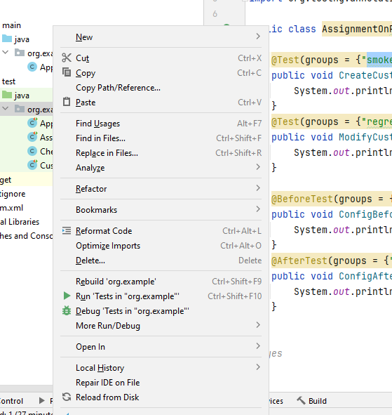

2- Click on the New option you will find an option named as Resource Bundle
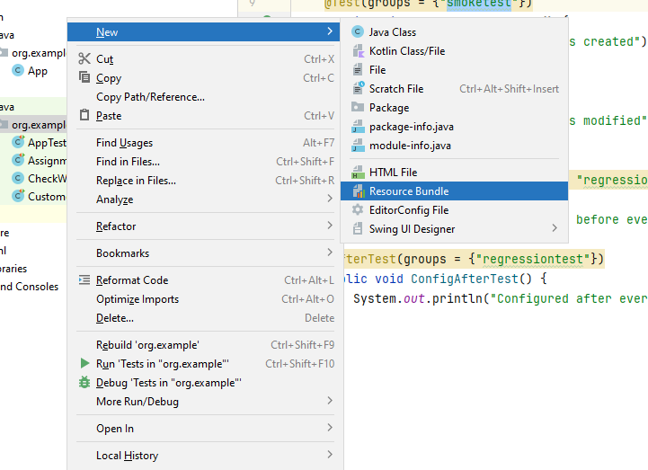

3- Click on the Refactor Bundle and then you will see another pop-up opens up there you can type the name of the xml file or whatever name you want to give for example I have taken TestNG.xml file and then below a check box is there asking to use the xml properties file tick on that option and then press OK button. TestNG.xml file will be created and then you can paste the below code but some changes are needed.

<?xml version="1.0" encoding="UTF-8"?>
<!DOCTYPE suite SYSTEM "http://testng.org/testng-1.0.dtd">
<suite name="Suite">
<test thread-count="5" name="Test">
<groups>
<run>
<include name="Smoke Test" />
</run>
</groups>
<classes>
<class name="SanjaySagar.TestNGgroup" />
</classes>
</test> <!-- Test -->
</suite> <!-- Suite →

4- <class name="SanjaySagar.TestNGgroup" /> = Over here in this line of code you need to give the name of your package inside which your class is there to locate the file for example I am giving “org.example.AssignmentOnPriortizingTheExecutionOFTestcase ( this is my class name) and then

<include name="Smoke Test" /> = over here in this line of code you need to give the same spelling of smoke testing as you have given in your class so that it can properly read and identify it.

For example: <include name="smoketest" /> since my class contains this spelling of smoke testing

Then you can run the xml file.

Class Code:

package org.example;

import org.testng.annotations.AfterTest;
import org.testng.annotations.BeforeTest;
import org.testng.annotations.Test;

public class AssignmentOnPriortizingTheExecutionOFTestcase {

@Test(groups = {"smoketest"})
public void CreateCustomerTest() {
System.out.println("Customer is created");
}
@Test(groups = {"regressiontest"})
public void ModifyCustomerTest() {
System.out.println("Customer is modified");
}

@BeforeTest(groups = {"smoketest", "regressiontest"})
public void ConfigBeforeTest() {
System.out.println("Configured before every testcase");
}
@AfterTest(groups = {"regressiontest"})
public void ConfigAfterTest() {
System.out.println("Configured after every testcase");
}

}
// yes

XML File Code:
<?xml version="1.0" encoding="UTF-8"?>
<!DOCTYPE suite SYSTEM "http://testng.org/testng-1.0.dtd">
<suite name="Suite">
<test thread-count="5" name="Test">
<groups>
<run>
<include name="smoketest" />
</run>
</groups>
<classes>
<class name="org.example.AssignmentOnPriortizingTheExecutionOFTestcase" />
</classes>
</test> <!-- Test -->
</suite>

package org.example;

import org.openqa.selenium.By;
import org.openqa.selenium.WebDriver;
import org.openqa.selenium.chrome.ChromeDriver;
import org.testng.annotations.AfterTest;
import org.testng.annotations.BeforeTest;
import org.testng.annotations.Test;

public class BonVoyageLoginUsingTestNGAnnotation{
static WebDriver driver;
@BeforeTest
public void init()
{
driver=new ChromeDriver();
driver.get("http://localhost:3001/");
}
@Test
public void test()
{
//Click on the login/signup button
driver.manage().window().maximize();
driver.findElement(By.xpath("//button[@tabindex='0']")).click();
//Move to the username
driver.findElement(By.id("email")).sendKeys("abhi@gmail.com");
//Move to the password
driver.findElement(By.id("password")).sendKeys("123456");
driver.findElement(By.xpath("//button[@type='submit']")).click();
//for logout
driver.findElement(By.xpath("//button[@tabindex='0']")).click();

}
@AfterTest
public void after_test()
{
driver.close();

}
}

@BeforeTest or @BeforeClass is used for preconditions for example : new ChromeDriver() code be part of this

@Test is used for containing the test cases for example: login into the application and
Logout is done above

@AfterClass or @AfterTest is used for postconditions or teardown conditions for example: when we want to close the webdriver( driver.close()) for example: driver.close() is used to close the webdriver.

Data Driven Testing: The testing which is conducted by keeping the test steps same but the data changes. It is also called as Parameterization.
Testing done with different sets of input data by keeping the test steps same.

How do we achieve Data Driven testing in TestNG
Ans: Using Data Provider.

Sample program of data driven testing
package org.example;
import org.openqa.selenium.By;
import org.openqa.selenium.WebDriver;
import org.openqa.selenium.chrome.ChromeDriver;
import org.openqa.selenium.firefox.FirefoxDriver;
import org.testng.annotations.DataProvider;
import org.testng.annotations.Test;

import java.util.concurrent.TimeUnit;

public class BonVoyageTest {
private static WebDriver driver;

@DataProvider
public Object[][] hellomethod() {
Object[][] data = new Object[3][2];

data[0][0]="abhi@gmail.com";
data[0][1]="123456";

data[1][0]="testuser43";
data[1][1]="zsdeg";

data[2][0]="getuser1";
data[2][1] = "pass123";

return data;
}

@Test(dataProvider = "hellomethod")
public void setData(String username, String password){
driver = new ChromeDriver();

driver.manage().timeouts().implicitlyWait(10, TimeUnit.SECONDS);

driver.get("http://localhost:3001/");

driver.findElement(By.xpath("//button[@tabindex='0']")).click();
//Move to the username
driver.findElement(By.id("email")).sendKeys(username);
//Move to the password
driver.findElement(By.id("password")).sendKeys(password);
driver.findElement(By.xpath("//button[@type='submit']")).click();
//for logout
driver.findElement(By.xpath("//button[@tabindex='0']")).click();
driver.quit();

}
}

import org.openqa.selenium.firefo.FirefoxDriver;
import org.testng.Assert;
import org.testng.annotations.Test;

public class DefaultPageTest {
static String expectedText="Please identify yourself?";
@Test
public void LoginPageTest() throws InterruptedException {
System.setProperty("webdriver.chrome.driver","C:\\Selenium\\chromedriver.exe");
WebDriver driver=new ChromeDriver();
driver.get("http://demo.actitime.com");
Thread.sleep(5000);
String actualText = driver.findElement(By.id("headerContainer")).getText();
Assert.assertEquals(actualText, expectedText,"Text ** is**not** present **in **the** Webpage");
}
@Test
public void LoginPageloglist(){
System.setProperty("webdriver.chrome.driver","C:\\Selenium\\chromedriver.exe");
WebDriver driver=new ChromeDriver();

driver.get("http://demo.actitime.com");
driver.manage().timeouts().implicitlyWait(90, TimeUnit.SECONDS);
boolean status= driver.findElement(By.id("logoContainer")).isDisplayed();
Assert.assertTrue(status,"logo not found");

}
}

Assertion is a feature available in TestNG used to verify the expected result of test case. Assert is a class available in TestNG which contains a lot of String methods which is used to verify 2 strings,collections..
Assert Methods:
- assertEquals()
- assertNotEquals()
- assertTrue()
- assertFalse()

// test ng.xml file usecases:
// grouping of test cases
// parallel running of testcases

Excel

- Working with the Excel File

There are two ways to work with Excel file:

1- Using .jxl jar files: We can only work with . XLS format. It doesn't support . xlsx format.
2- Apache Poi supports both . XLS and .xlsx format.

https://jexcelapi.sourceforge.net/resources/javadocs/current/docs/jxl/Workbook.html
How to get data from Excel Sheet
1. Open Workbook in Read Mode.
2. Get the control of the Data Sheet.
3. Get the control of the row.
4. Get the cell value.
Create an excel sheet and save it with .xls(Test.xls)

Before that Add this dependency:
<!-- https://mvnrepository.com/artifact/net.sourceforge.jexcelapi/jxl -->
<dependency>
<groupId>net.sourceforge.jexcelapi</groupId>
<artifactId>jxl</artifactId>
<version>2.6.12</version>
</dependency>

Reading Data from Excel File
package ProjPackage;
import java.io.FileInputStream;
import java.io.IOException;
import jxl.Sheet;
import jxl.Workbook;
import jxl.read.biff.BiffException;

public class ReadExcelfile {

public void readExcel() throws BiffException, IOException {
String FilePath = "D:\\Test.xls";
FileInputStream fs = new FileInputStream(FilePath);
Workbook wb = Workbook.getWorkbook(fs);

// TO get the access to the sheet
Sheet sh = wb.getSheet("Sheet1");

// To get the number of rows present in sheet
int totalNoOfRows = sh.getRows();

// To get the number of columns present in sheet
int totalNoOfCols = sh.getColumns();

for (int row = 0; row < totalNoOfRows; row++) {

for (int col = 0; col < totalNoOfCols; col++) {
System.out.print(sh.getCell(col, row).getContents() + "\t");
}
System.out.println();
}
}

public static void main(String args[]) throws BiffException, IOException {
ReadExcelfile DT = new ReadExcelfile();
DT.readExcel();
}
}
Writing Data to an Excel File:
package ProjPackage;

import org.apache.poi.ss.usermodel.WorkbookFactory;
import java.io.File;
import java.io.IOException;
import jxl.Workbook;
import jxl.write.Label;
import jxl.write.WritableSheet;
import jxl.write.WritableWorkbook;
import jxl.write.WriteException;
import jxl.write.biff.RowsExceededException;

public class WriteExcel {

public static void main(String[] args) throws RowsExceededException, WriteException, IOException {

File file = new File("D:\\Datasheetnew.xls");

WritableWorkbook wb = Workbook.createWorkbook(file);
WritableSheet sht = wb.createSheet("data", 0);

Label ll = new Label(0, 0, "username");
sht.addCell(ll);
sht.addCell(new Label(0, 1, "Password"));
sht.addCell(new Label(0, 2, "Result"));

wb.write();
wb.close();
System.out.println("Workbook is created");
}

}

Workbook workbook = Workbook.getWorkbook(new File("myfile.xls")); Sheet sheet = workbook.getSheet(0); for (int i = 0; i < sheet.getRows(); i++) { boolean c1Empty = sheet.getCell(0, i).getContents().isEmpty(); boolean c2Empty = sheet.getCell(1, i).getContents().isEmpty(); boolean c3Empty = sheet.getCell(2, i).getContents().isEmpty(); boolean c4Empty = sheet.getCell(3, i).getContents().isEmpty(); if (c1Empty && c2Empty && c3Empty && c4Empty) { throw new RuntimeException("If the first three columns are empty then the fourth column can not empty."); } // Redundant //if (c4Empty && c1Empty && c2Empty && c3Empty) { // throw new RuntimeException("If the fourth column is empty then all the three columns should not be empty."); //}


Program to Read Data from Excel File using Apache Poi
package ProjPackage;

import java.io.File;

import java.io.FileInputStream;

import java.io.IOException;

import org.apache.poi.hssf.usermodel.HSSFWorkbook;
import org.apache.poi.ss.usermodel.Cell;
import org.apache.poi.ss.usermodel.Row;

import org.apache.poi.ss.usermodel.Sheet;

import org.apache.poi.ss.usermodel.Workbook;
import org.apache.poi.xssf.usermodel.XSSFSheet;
import org.apache.poi.xssf.usermodel.XSSFWorkbook;

public class ReadExcelPoi {

public static void main(String [] args) throws IOException{
//I have placed an excel file 'Test.xlsx' in my D Driver
FileInputStream fis = new FileInputStream("D:\\TestCase.xlsx");
XSSFWorkbook workbook = new XSSFWorkbook(fis);
XSSFSheet sheet = workbook.getSheetAt(0);

Row row = sheet.getRow(0);
Cell cell = row.getCell(0);
System.out.println(cell);
System.out.println(sheet.getRow(0).getCell(1));

}

}

Read username and Password from login.xlsx and enter that data in BonVoyage application then print pass if able to login otherwise fail

4  5  6  7  8  9  10  11  12  13  14  15  16  17  18  19  20  21  22  23  24  25  26  27  28  29  30  31  32  33  34  35  36  37  38  39  40  41  42  43  44  45  46  47  48  49  50  51  52  53  54  55  56  57  58  59  60  61  62  63  64  65  66  67  68  69  70  71  72  73  74  75  76  77  78  79  80  81  82  83  84  85  86  87  88  89  90 | package tests;  import java.io.File;  import java.io.FileInputStream;  import java.io.FileOutputStream;  import java.io.IOException;  import java.util.concurrent.TimeUnit;  import org.apache.poi.ss.usermodel.Cell;  import org.apache.poi.xssf.usermodel.XSSFCell;  import org.apache.poi.xssf.usermodel.XSSFSheet;  import org.apache.poi.xssf.usermodel.XSSFWorkbook;  import org.openqa.selenium.By;  import org.openqa.selenium.WebDriver;  import org.openqa.selenium.chrome.ChromeDriver;  import org.testng.annotations.BeforeTest;  import org.testng.annotations.Test;  public class DataDrivenTest {  WebDriver driver;  XSSFWorkbook workbook;  XSSFSheet sheet;  XSSFCell cell;  @BeforeTest  public void TestSetup(){  // To set the path of the Chrome driver.  System.setProperty("webdriver.chrome.driver", System.getProperty("user.dir")+"\\src\\test\\java\\drivers\\chromedriver.exe");  driver = new ChromeDriver();  // To launch facebook  driver.get("http://www.facebook.com/");  // To maximize the browser  driver.manage().window().maximize();  // implicit wait  driver.manage().timeouts().implicitlyWait(20, TimeUnit.SECONDS);  }  @Test  public void ReadData() throws IOException, Exception{  // Import excel sheet.  File src=new File("D:\\Test.xlsx");  // Load the file.  FileInputStream fis = new FileInputStream(src);  // Load he workbook.  workbook = new XSSFWorkbook(fis);  // Load the sheet in which data is stored.  sheet= workbook.getSheet("Sheet1");  for(int i=1; i<=sheet.getLastRowNum(); i++){  /*I have added test data in the cell A2 as "testemailone@test.com" and B2 as "password"  Cell A2 = row 1 and column 0. It reads first row as 0, second row as 1 and so on  and first column (A) as 0 and second column (B) as 1 and so on*/  // Import data for Email.  cell = sheet.getRow(i).getCell(0);  cell.setCellType(Cell.CELL_TYPE_STRING);  driver.findElement(By.xpath("//input[@type='email'][@name='email']")).clear();  driver.findElement(By.xpath("//input[@type='email'][@name='email']")).sendKeys(cell.getStringCellValue());  // Import data for password.  cell = sheet.getRow(i).getCell(1);  cell.setCellType(Cell.CELL_TYPE_STRING);  driver.findElement(By.xpath("//input[@type='password'][@name='pass']")).clear();  driver.findElement(By.xpath("//input[@type='password'][@name='pass']")).sendKeys(cell.getStringCellValue());  // To click on Login button  driver.findElement(By.xpath("//input[@type='submit'][@id='u_0_5']")).click();  //To write data in the excel  FileOutputStream fos=new FileOutputStream(src);  // Message to be written in the excel sheet  String message = "Pass";  // Create cell where data needs to be written.  sheet.getRow(i).createCell(2).setCellValue(message);  // finally write content  workbook.write(fos);  // To click on Account settings dropdown  driver.findElement(By.xpath("//div[text()='Account Settings']")).click();  // To click on logout button  driver.findElement(By.xpath("//text()[.='Log Out']/ancestor::span[1]")).click();  // close the file  fos.close();  }  }  }

public class DataDrivenTest {
WebDriver driver;
XSSFWorkbook workbook;
XSSFSheet sheet;
XSSFCell cell;
@BeforeTest
public void initialization(){
// To set the path of the Chrome driver.
System.setProperty("webdriver.chrome.driver", System.getProperty("user.dir")+"\\src\\test\\java\\drivers\\chromedriver.exe");
driver = new ChromeDriver();

// To launch facebook
driver.get("http://www.facebook.com/");
// To maximize the browser
driver.manage().window().maximize();
// implicit wait
driver.manage().timeouts().implicitlyWait(20, TimeUnit.SECONDS);
}

@Test
public void fbLoginLogout() throws IOException{
// Import excel sheet.
File src=new File("D:\\Test.xlsx");
// Load the file.
FileInputStream fis = new FileInputStream(src);
// Load he workbook.
workbook = new XSSFWorkbook(fis);
// Load the sheet in which data is stored.
sheet= workbook.getSheetAt(0);
for(int i=1; i<=sheet.getLastRowNum(); i++){
/*I have added test data in the cell A2 as "testemailone@test.com" and B2 as "password"
Cell A2 = row 1 and column 0. It reads first row as 0, second row as 1 and so on
and first column (A) as 0 and second column (B) as 1 and so on*/
// Import data for Email.
cell = sheet.getRow(i).getCell(0);
cell.setCellType(Cell.CELL_TYPE_STRING);
driver.findElement(By.xpath("//input[@type='email'][@name='email']")).clear();
driver.findElement(By.xpath("//input[@type='email'][@name='email']")).sendKeys(cell.getStringCellValue());
// Import data for password.
cell = sheet.getRow(i).getCell(1);
cell.setCellType(Cell.CELL_TYPE_STRING);
driver.findElement(By.xpath("//input[@type='password'][@name='pass']")).clear();
driver.findElement(By.xpath("//input[@type='password'][@name='pass']")).sendKeys(cell.getStringCellValue());
// To click on Login button
driver.findElement(By.xpath("//input[@type='submit'][@id='u_0_5']")).click();
// To click on Account settings dropdown
driver.findElement(By.xpath("//div[text()='Account Settings']")).click();
// To click on logout button
driver.findElement(By.xpath("//text()[.='Log Out']/ancestor::span[1]")).click();
}
}
}

POI Dependency

<dependency>
<groupId>org.apache.poi</groupId>
<artifactId>poi</artifactId>
<version>4.1.1</version>
</dependency>
<dependency>
<groupId>org.apache.poi</groupId>
<artifactId>poi-ooxml</artifactId>
<version>4.1.1</version>
</dependency>

package org.example;
import java.io.File;

import java.io.FileInputStream;

import java.io.IOException;

import org.apache.poi.hssf.usermodel.HSSFWorkbook;
import org.apache.poi.ss.usermodel.Cell;
import org.apache.poi.ss.usermodel.Row;

import org.apache.poi.ss.usermodel.Sheet;

import org.apache.poi.ss.usermodel.Workbook;
import org.apache.poi.xssf.usermodel.XSSFSheet;
import org.apache.poi.xssf.usermodel.XSSFWorkbook;

public class ApachePOI {
public static void main(String [] args) throws IOException{
//I have placed an excel file 'Test.xlsx' in my D Driver
FileInputStream fis = new FileInputStream("C:\\Users\\snehal.gorde\\Downloads\\Login.xlsx");
XSSFWorkbook workbook = new XSSFWorkbook(fis);
XSSFSheet sheet = workbook.getSheetAt(0);

Row row = sheet.getRow(0);
Cell cell = row.getCell(0);
System.out.println(cell);
System.out.println(sheet.getRow(0).getCell(1));

}

}

HSSF (Horrible Spreadsheet Format) − It is used to read and write xls format of MS-Excel files. XSSF (XML Spreadsheet Format) − It is used for xlsx file format of MS-Excel

Jxl jar file s supports xls format
Apache Poi supports both xls format and xlsx format

package com.glo;

import java.io.File;
import java.io.FileInputStream;
import java.io.FileOutputStream;
import java.io.IOException;
import java.util.concurrent.TimeUnit;

import org.apache.poi.ss.usermodel.Cell;
import org.apache.poi.xssf.usermodel.XSSFCell;
import org.apache.poi.xssf.usermodel.XSSFSheet;
import org.apache.poi.xssf.usermodel.XSSFWorkbook;
import org.openqa.selenium.By;
import org.openqa.selenium.WebDriver;
import org.openqa.selenium.chrome.ChromeDriver;
import org.testng.annotations.BeforeTest;
import org.testng.annotations.Test;

public class BonVoyagePOI {
WebDriver driver;
XSSFWorkbook workbook;
XSSFSheet sheet;
XSSFCell cell;

@BeforeTest
public void TestSetup(){
// To set the path of the Chrome driver.
driver = new ChromeDriver();
// To launch facebook
// driver.get("http://localhost:3001/");
// // To maximize the browser
// driver.manage().window().maximize();
// // implicit wait
// driver.manage().timeouts().implicitlyWait(20, TimeUnit.SECONDS);
}

@Test
public void ReadData() throws IOException, Exception{
// Import excel sheet.
File src=new File("C:\\Users\\chetan.kuhite\\Desktop\\All Project files\\TestNG\\ApachePOI\\src\\main\\java\\com\\glo\\TestLoginPassword.xlsx");
// Load the file.
FileInputStream fis = new FileInputStream(src);
// Load the workbook.
workbook = new XSSFWorkbook(fis);

// Load the sheet in which data is stored.
sheet= workbook.getSheet("Sheet1");

System.out.println(sheet.getLastRowNum());

for(int i=1; i<=sheet.getLastRowNum(); i++){
driver.get("http://localhost:3001/");
// To maximize the browser
driver.manage().window().maximize();
// implicit wait
driver.manage().timeouts().implicitlyWait(20, TimeUnit.SECONDS);

/*I have added test data in the cell A2 as "testemailone@test.com" and B2 as "password"
Cell A2 = row 1 and column 0. It reads first row as 0, second row as 1 and so on
and first column (A) as 0 and second column (B) as 1 and so on*/
// Import data for Email.

driver.findElement(By.xpath("//*[@id=\"root\"]/div[1]/div/header/div/div[2]/div/button")).click();

cell = sheet.getRow(i).getCell(0);

driver.findElement(By.id("email")).clear();
driver.findElement(By.id("email")).sendKeys(cell.getStringCellValue());
// Import data for password.
cell = sheet.getRow(i).getCell(1);
driver.findElement(By.id("password")).clear();
driver.findElement(By.id("password")).sendKeys(cell.getStringCellValue());
// To click on Login button
driver.findElement(By.xpath("//*[@id=\"root\"]/main/div/div/div[2]/div/form/button")).click();
//To write data in the excel
FileOutputStream fos=new FileOutputStream(src);
// Message to be written in the excel sheet
String message = "Pass";
// Create cell where data needs to be written.
sheet.getRow(i).createCell(2).setCellValue(message);

// finally write content
workbook.write(fos);
// To click on logout button
driver.findElement(By.xpath("//button[text()='Logout']")).click();
// close the file
fos.close();

}
}
}

//Pass and Failed

package com.glo;

import java.io.File;
import java.io.FileInputStream;
import java.io.FileOutputStream;
import java.io.IOException;
import java.util.concurrent.TimeUnit;

import org.apache.poi.ss.usermodel.Cell;
import org.apache.poi.xssf.usermodel.XSSFCell;
import org.apache.poi.xssf.usermodel.XSSFSheet;
import org.apache.poi.xssf.usermodel.XSSFWorkbook;
import org.openqa.selenium.By;
import org.openqa.selenium.WebDriver;
import org.openqa.selenium.chrome.ChromeDriver;
import org.testng.annotations.BeforeTest;
import org.testng.annotations.Test;

public class BonVoyagePOI {
WebDriver driver;
XSSFWorkbook workbook;
XSSFSheet sheet;
XSSFCell cell;

@BeforeTest
public void TestSetup(){
// To set the path of the Chrome driver.
driver = new ChromeDriver();
// To launch facebook
// driver.get("http://localhost:3001/");
// // To maximize the browser
// driver.manage().window().maximize();
// // implicit wait
// driver.manage().timeouts().implicitlyWait(20, TimeUnit.SECONDS);
}

@Test
public void ReadData() throws IOException, Exception{
// Import excel sheet.
File src=new File("C:\\Users\\chetan.kuhite\\Desktop\\All Project files\\TestNG\\ApachePOI\\src\\main\\java\\com\\glo\\TestLoginPassword.xlsx");
// Load the file.
FileInputStream fis = new FileInputStream(src);
// Load the workbook.
workbook = new XSSFWorkbook(fis);

// Load the sheet in which data is stored.
sheet= workbook.getSheet("Sheet1");

System.out.println(sheet.getLastRowNum());

for(int i=1; i<=sheet.getLastRowNum(); i++){
driver.get("http://localhost:3001/");
// To maximize the browser
driver.manage().window().maximize();
// implicit wait
driver.manage().timeouts().implicitlyWait(20, TimeUnit.SECONDS);

/*I have added test data in the cell A2 as "testemailone@test.com" and B2 as "password"
Cell A2 = row 1 and column 0. It reads first row as 0, second row as 1 and so on
and first column (A) as 0 and second column (B) as 1 and so on*/
// Import data for Email.

// click on the login button driver.findElement(By.xpath("//*[@id=\"root\"]/div[1]/div/header/div/div[2]/div/button")).click();

cell = sheet.getRow(i).getCell(0);

driver.findElement(By.id("email")).clear();
driver.findElement(By.id("email")).sendKeys(cell.getStringCellValue());
// Import data for password.
cell = sheet.getRow(i).getCell(1);
driver.findElement(By.id("password")).clear();
driver.findElement(By.id("password")).sendKeys(cell.getStringCellValue());
// To click on Login button
driver.findElement(By.xpath("//*[@id=\"root\"]/main/div/div/div[2]/div/form/button")).click();

FileOutputStream fos=new FileOutputStream(src);

try{
// checking whether the logout button is displayed or not
driver.findElement(By.xpath("//button[text()='Logout']")).isDisplayed();
driver.findElement(By.xpath("//button[text()='Logout']")).click();
String message = "Pass";
sheet.getRow(i).createCell(2).setCellValue(message);
// finally write content
workbook.write(fos);
}catch (Exception e){
String message = "Fail";
sheet.getRow(i).createCell(2).setCellValue(message); // storing in a buffer
// finally write content
workbook.write(fos);
}
//
//// To click on logout button
// driver.findElement(By.xpath("//button[text()='Logout']")).click();
// close the file
fos.close();

}
}
}

Selenium Grid ( Advance Topics ) :

try {
// Define the Grid Hub URL
URL gridUrl = new URL("http://localhost:4444/wd/hub");
// Set Chrome options (you can use FirefoxOptions, EdgeOptions, etc.)
ChromeOptions options = new ChromeOptions();
// Initialize RemoteWebDriver with Grid URL and ChromeOptions
WebDriver driver = new RemoteWebDriver(gridUrl, options);
// Open a website
driver.get("https://www.google.com");
// Perform actions and assertions here
System.out.println("Title: " + driver.getTitle());
// Quit the driver
driver.quit();
} catch (Exception e) {
e.printStackTrace();
}
}

package package1;
import org.openqa.selenium.WebDriver;
import org.openqa.selenium.remote.RemoteWebDriver;
import org.openqa.selenium.chrome.ChromeOptions;
import java.net.URL;
public class SeleniumGrid2 {

public static void main(String[] args) {

try {
// Define the Grid Hub URL
URL gridUrl = new URL("http://localhost:4444/wd/hub");
// Set Chrome options (you can use FirefoxOptions, EdgeOptions, etc.)
ChromeOptions options = new ChromeOptions();
// Initialize RemoteWebDriver with Grid URL and ChromeOptions
WebDriver driver = new RemoteWebDriver(gridUrl, options);
// Open a website
driver.get("https://www.google.com");
// Perform actions and assertions here
System.out.println("Title: " + driver.getTitle());
// Quit the driver
driver.quit();
} catch (Exception e) {
e.printStackTrace();
}
}

}

- cell: This refers to an individual cell in the Excel sheet, which can hold various types of data (string, numeric, boolean, etc.).
- setCellType(): This method is part of the Apache POI library, which is used to manipulate Excel files. It sets the type of the cell’s value.
- Cell.CELL_TYPE_STRING: This is a constant that tells Apache POI to treat the cell’s value as a string. Even if the cell contains a numeric or boolean value, by setting the type to CELL_TYPE_STRING, the value is converted into a string representation.

In the context of Selenium Grid, Standalone mode refers to a simplified setup where a single instance of Selenium is used to perform both the roles of a hub and a node. This means the server can accept test requests and execute them without needing multiple nodes or a complex grid setup.
Here are the key points about Standalone mode:
- Single Server: Both the Selenium hub (which receives test execution requests) and the node (which executes those tests) run in a single process.
- Easy Setup: You don't need to configure separate hub and node machines, making it easier for small-scale testing or individual projects.
- Good for Local Testing: It is ideal for local testing or when you don't need the scale of a distributed grid.

Selenium Grid, an essential component of the Selenium suite, enables you to run test cases simultaneously in different browsers and browser versions. Running tests sequentially on a single machine is always time-consuming, as you can only load a few browsers on your local machine, limiting testing capabilities (e.g., Windows couldn’t test Safari).
This is where the Selenium Grid setup allows testing on all major browsers, operating systems, and mobile devices, ensuring broad browser coverage and a uniform user experience.

TABLE OF CONTENTS
- What is a Selenium Grid?
- Why Use Selenium Grid?
- Features of Selenium Grid
- Components of Selenium Grid
- How to Configure a Selenium Grid Setup?
- How to Perform Parallel Testing With Selenium Grid?
- Parallel Testing At Scale Using LambdaTest
- Frequently Asked Questions (FAQs)

What is a Selenium Grid?
Selenium Grid helps in running the Selenium tests on remote machines. It makes use of a proxy server that is run using a Selenium server and allows for the maintenance of different browser configurations at the central level. It enables the tests to run in parallel on other browser versions, thus helping perform cross browser testing.
Moreover, Selenium Grid allows parallel testing against various browsers and OS combinations through a client-server model. Here, the server is known as the Hub, which has multiple clients with which to interact.

Why Use Selenium Grid?
Selenium Grid eases the various tasks while performing automated testing. Here is why you should use Selenium Grid setup to run your test suites:
- Open Source and Free: Selenium Grid is an open-source project. Teams can use it for free. The documentation is updated regularly with every release, making things like installation, configuration, and usage easier for the users.
- Enables Cross Browser Testing: Multiple browsers are gaining popularity, and every person prefers to use the browser of his choice for browning websites. It becomes necessary for businesses to test their websites on multiple browsers. Selenium Grid 4 enables the software teams to perform cross browser testing quickly, allowing them to configure multiple browsers easily.
- Supports Multiple Browser Versions: Another important feature is that Selenium Grid allows users to configure multiple browser versions easily. This helps test websites in different browsers and their versions, enabling teams to detect the issues and fix them at the earliest.
- Supports Parallel Testing: This is one of the most important features behind using Selenium Grid for testing. It helps run the tests in parallel, allowing the teams to save time on test execution and get faster results and feedback on the builds.
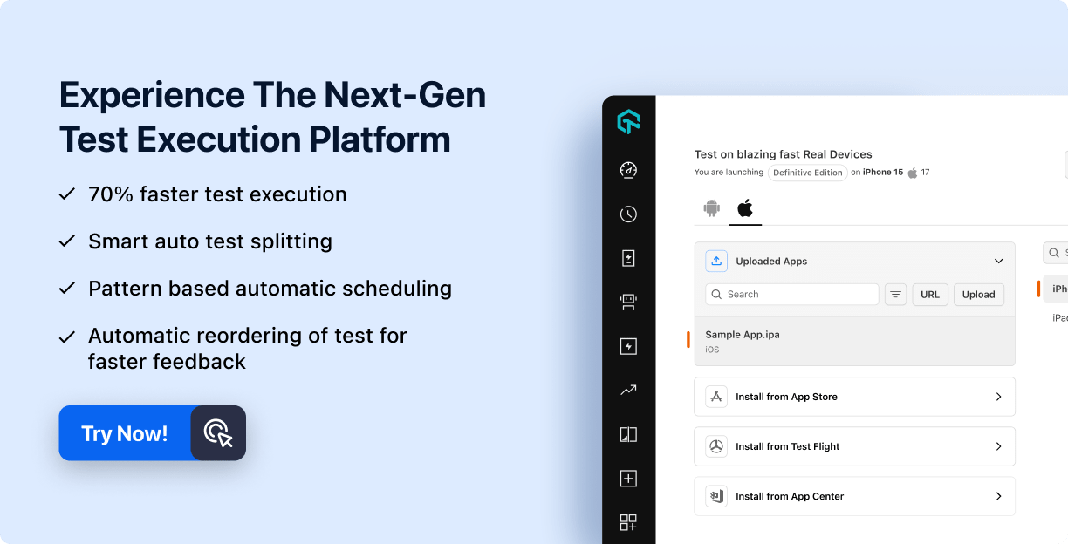

Features of Selenium Grid
The following are the salient features of Selenium Grid 4:
- Architecture Support: In the earlier version of Selenium Grid, only two processes were available, i.e., Hub and Nodes. The Selenium Grid 4 architecture supports the following six processes, which allows for deployment in different ways:
  - Router
  - Distributor
  - Session Map
  - New Session Queue
  - Node
  - Event Bus
- Different Grid Roles: Selenium Grid can be configured in the following three ways:
  - Standalone Mode
  - Classical Grid (Hub and Node)
  - Fully Distributed (Event Bus, New Session Queue, Session Map, Distributor, Router and Node)
- Docker Support: Selenium Grid offers out-of-the-box support for Docker. The Docker daemon runs on port 2375.
- Observability: Observability in Selenium Grid allows understanding and debugging of internal working as it is designed to be fully distributed. The following three are the main pillars that help in providing detailed insights into observability.
  - Traces
  - Metrics
  - Logs
- GraphQL Query Support: GraphQL, a query language for APIs, can be used to query and fetch the data that the user requires. With Selenium Grid, GraphQL queries are supported. A simple query can fetch the details of the session, node and grid, current session count, max session count, all session details, etc.
- Support for Customizing a Node: With Selenium Grid, the Nodes can be customized and updated according to the prerequisite for test execution. For example, doing some additional setup before the session begins execution, similarly running clean-up jobs post-session is complete.
- Support for External Data Store: Selenium Grid allows us to save the information related to the currently running sessions into an external data store that could be backed by our favorite database, or the Redis Cache system can also be used.
Note: With Selenium 4 in place, Selenium Grid 3 has been deprecated, and the official Selenium documentation recommends using the Selenium Grid 4. To learn about the changes between Selenium Grid 3 and Selenium 4, refer to Selenium 3 vs Selenium 4.
You can also subscribe to the LambdaTest YouTube Channel and stay updated with the latest video tutorials on Selenium testing.

Components of Selenium Grid
The following are the six main components of Selenium Grid:
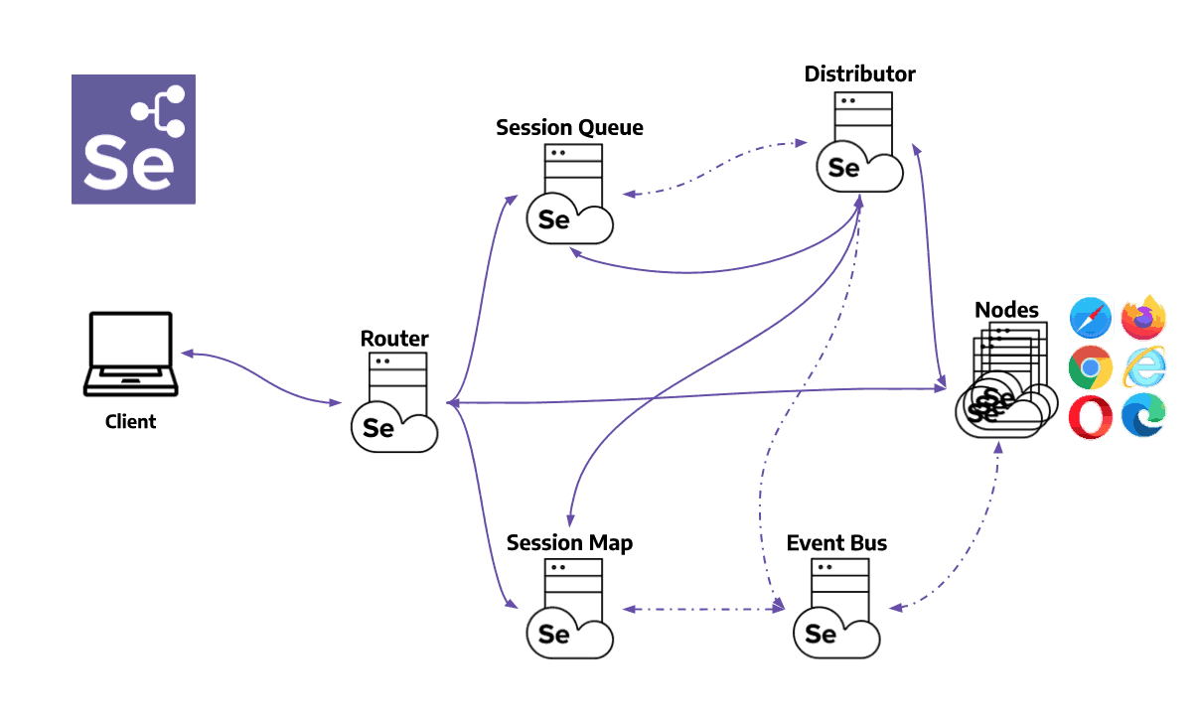
Source
- Router: Acts as the gateway for the grid, receiving external requests and directing them to the right component for handling.
- Distributor: Manages the registration and capabilities of Nodes in the grid. It also assigns new session requests to the appropriate Nodes from the Session Queue and updates the Grid’s model with Node status.
- Session Map: Stores the links between Session IDs and Nodes, facilitating efficient request routing by the Router.
- Session Queue: Holds incoming session requests in a First In, First Out (FIFO) order. It includes settings for request timeouts and retry intervals, ensuring organized and efficient processing of requests.
- Node: Executes tests within a distributed network. To receive appropriate test requests, Nodes with specific configurations must register with the Distributor.
- Event Bus: Facilitates internal communication between grid components using messages to avoid direct HTTP calls. It is activated when the grid starts in fully distributed mode.

How to Configure a Selenium Grid Setup?
For Selenium Grid setup, here are some prerequisites that you need to follow:
- Ensure system installation of Java Runtime Environment (JRE) or Java Development Kit (JDK). Prefer the latest JDK version; however, any version above Java 11 suffices (Java 11 is the minimum version supported by Selenium).
- Download Selenium Standalone server JAR files.
- Download the Java JAR files.
Now, let’s see the steps for Selenium Grid setup implementation:
Step 1: Configure a Standalone Grid
Standalone Grid provides a fully functional grid with a single command within a single process. It perfectly combines all the grid components and can run on a single machine.
The following command can be run from the terminal to start the Selenium Grid in Standalone Mode:
1 | java -jar selenium-server-<version>.jar standalone
Ensure you navigate to the folder where you downloaded and extracted the Selenium JAR files. These files are located on My Computer in the H:\selenium_grid\ folder.
After executing the command, navigate to http://localhost:4444 to check the fully functional Selenium Grid.
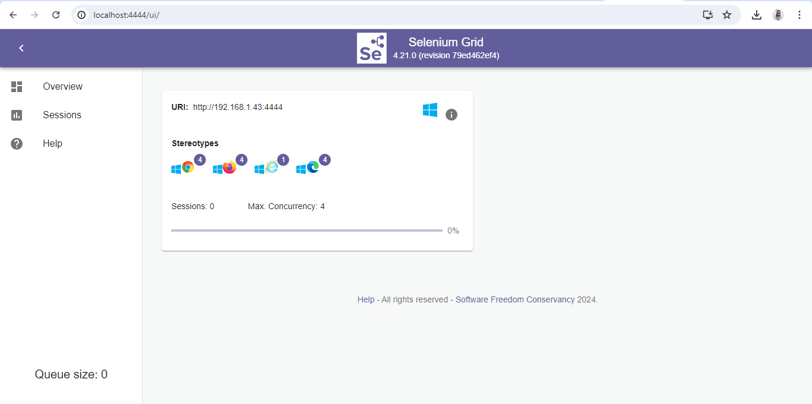
It can be seen that Selenium Grid is fully functional with four instances of Chrome, Firefox, Edge, and IE browsers.
Step 2: Configure Hub and Nodes
To start the Hub, open a command prompt or terminal, navigate to the directory where the Selenium Standalone Server JAR file is saved, and run the below command:
1 | java -jar selenium-server-<version>.jar hub
This command would launch a Selenium Grid hub on port 4444 by default. It can be verified by navigating to http://localhost:4444
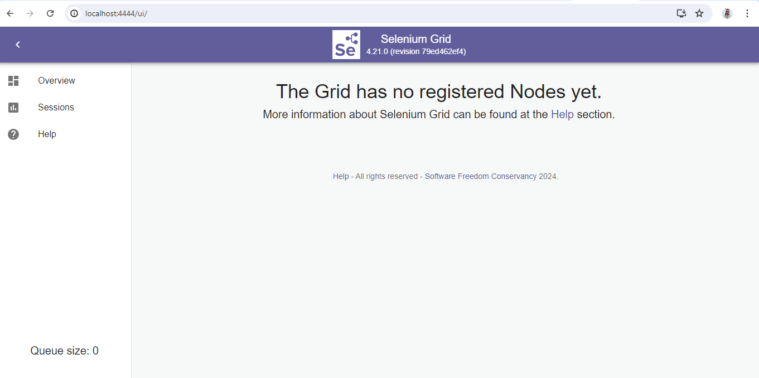
Next, we need to configure the Nodes to make it fully functional.
After the Hub is started, the Nodes need to be set up to run the browser session for test execution. The Nodes can be set up in different machines. However, it should be noted that these machines should have a JDK/JRE already installed. The Nodes can also be set up on the same machine Hub runs.
To configure a Node, open a command prompt or terminal and navigate to the directory where you saved the browser driver files.
Step 3: Configure Chrome Browser in the Selenium Grid Setup
The following command should be executed in the new instance of the command prompt to start a Node with the Chrome browser:
1 | java -jar selenium-server-4.21.0.jar node --detect-drivers false --driver-configuration display-name="Chrome" max-sessions=1 stereotype="{\"browserName\":\"chrome\",\"platformName\": \"Windows 11\"}" --port 6161
The above command will start a Node with Chrome browser with one session on port 6161. If we need to increase the session, we can update the value for the max-sessions parameter in the above command.
The Node can be verified on the Selenium Grid UI by navigating to http://localhost:4444.
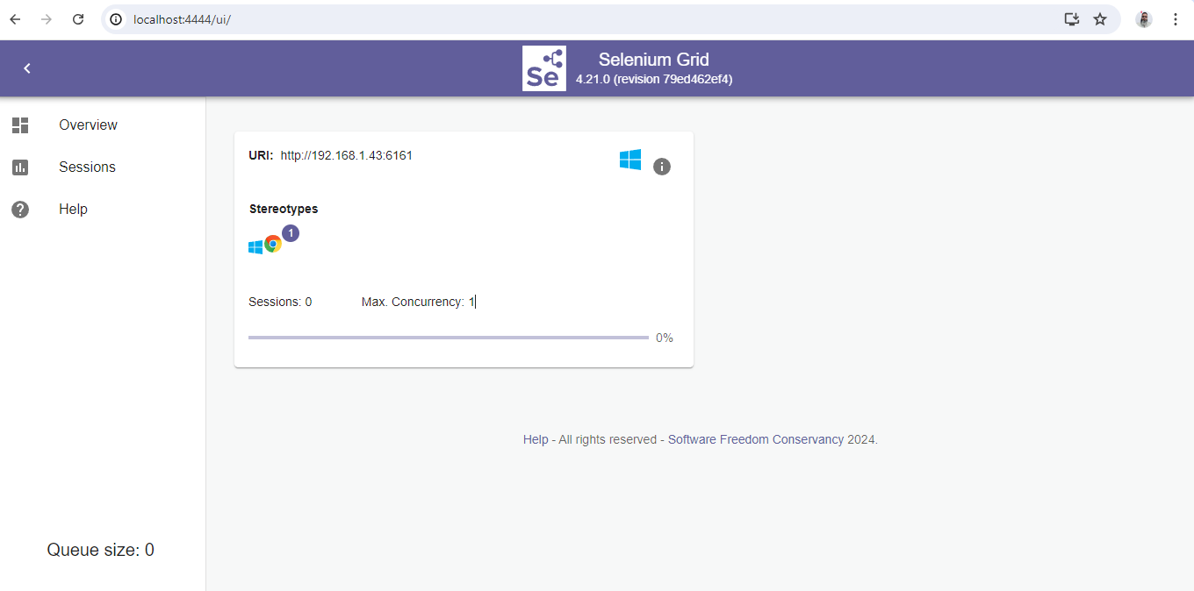
Let’s now add another node with the Firefox browser to the grid.
Step 4: Configure Firefox Browser in the Selenium Grid Setup
Open a new instance of the command prompt or terminal and run the following command:
1 | java -jar selenium-server-4.21.0.jar node --detect-drivers false --driver-configuration display-name="Firefox" max-sessions=2 stereotype="{\"browserName\":\"firefox\",\"platformName\": \"Windows 11\"}" --port 6162
The above command will spin a new Node with the two Firefox browser sessions running. Note that we have started this Node on a different port,i.e., 6162.
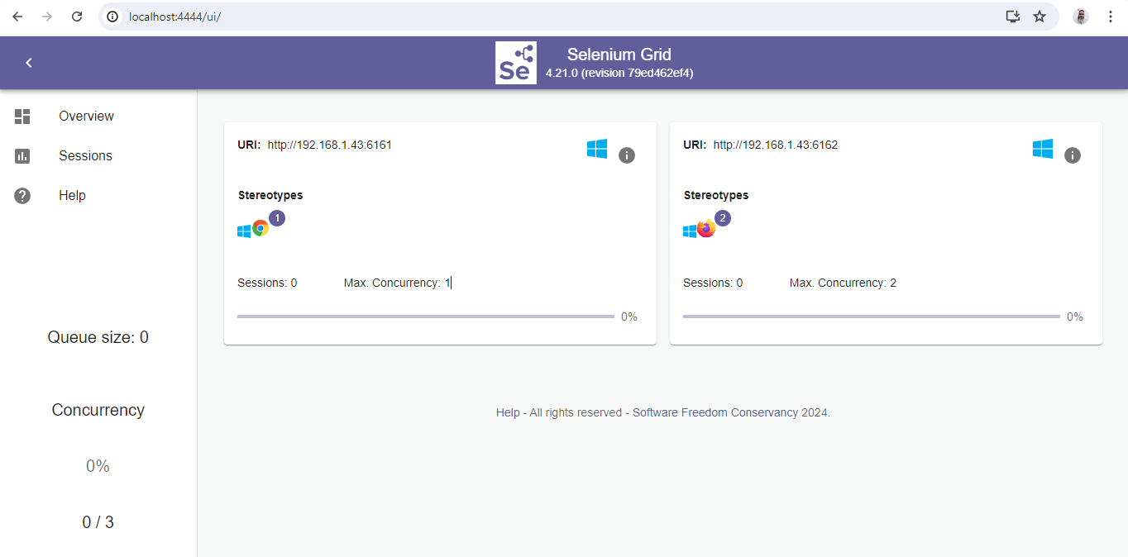
Let’s now add a third Node with the Microsoft Edge browser.
Step 5: Configure Edge Browser in the Selenium Grid Setup
Open a new instance of the command prompt or terminal and run the following command:
1 | java -jar selenium-server-4.21.0.jar node --detect-drivers false --driver-configuration display-name="Edge" max-sessions=3 stereotype="{\"browserName\":\"MicrosoftEdge\",\"platformName\": \"Windows 11\"}" --port 6163
The above command will configure three Edge browser sessions in a new Node on port 6163.
Let’s verify the addition of a new Node by navigating and checking http://localhost:4444.
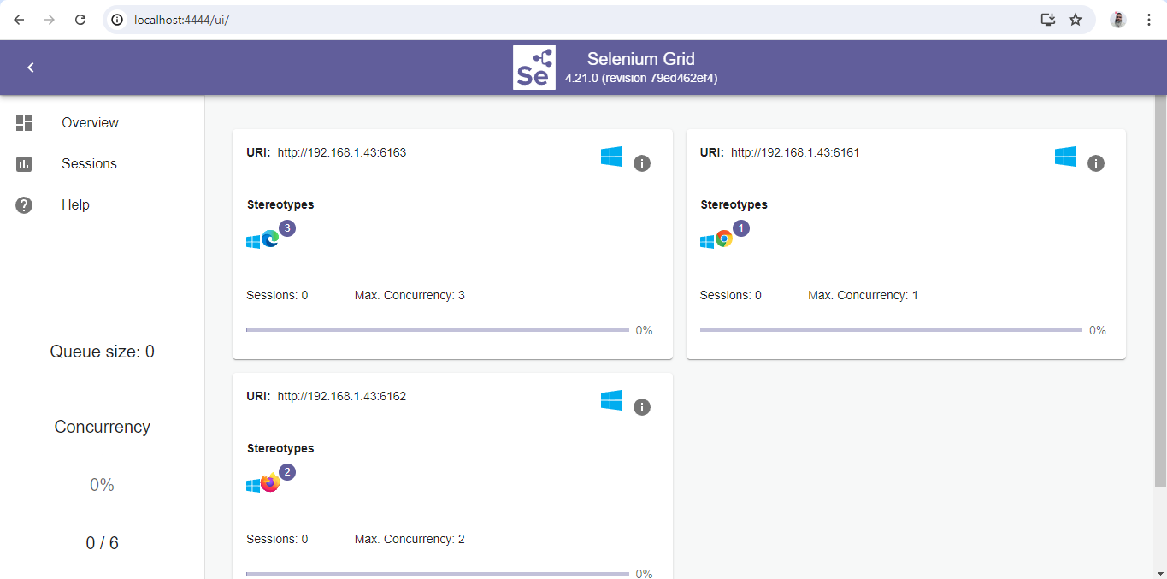
Step 6: Configure a Distributed Grid
Each component is launched independently in a Distributed Grid setup, preferably on separate machines. Follow the following steps to configure the Distributed Grid:
- Start the Event Bus
- Open a new terminal or command prompt and run the following command to start the Event Bus. Event Bus helps in internal communication between different grid components.
1 | java -jar selenium-server-4.21.0.jar event-bus --publish-events tcp://localhost:4442 --subscribe-events tcp://localhost:4443 --port 5557
- Start the New Session Queue
- Start the New Session Queue by adding the new session requests to a queue. The Distributor queries it. The following command should be run after opening a new command prompt:
1 | java -jar selenium-server-4.21.0.jar sessionqueue --port 5559
- Start the Session Map
- Start the Session Map next, which will interact with the Event Bus and map session IDs to the Node where the session is running.
Open a new command prompt and run the following command:
1 | java -jar selenium-server-4.21.0.jar sessions --publish-events tcp://localhost:4442 --subscribe-events tcp://localhost:4443 --port 5556
- Start the Distributor
- The next step is to start the Distributor which queries the New Session Queue for checking new session requests. When finding the matching capabilities, it assigns a Node to the New Session request.
Open the command prompt and run the following command:
1 | java -jar selenium-server-4.21.0.jar distributor --publish-events tcp://localhost:4442 --subscribe-events tcp://localhost:4443 --sessions http://localhost:5556 --sessionqueue http://localhost:5559 --port 5553 --bind-bus false
- Start the Router
- The next step is to start the Router, which will direct new session requests to the queue and route requests for active sessions to the Node handling that session.
Open the command prompt and run the following command:
1 | java -jar selenium-server-4.21.0.jar router --sessions http://localhost:5556 --distributor http://localhost:5553 --sessionqueue http://localhost:5559 --port 4444
- Start the Nodes
- Start the Node to launch the browser sessions, which will eventually help run our automated tests.
The following command will add one Node with four Chrome, Firefox, and Edge browser sessions. It will also spin one session of IE browser by default.
1 | java -jar selenium-server-4.21.0.jar node --publish-events tcp://localhost:4442 --subscribe-events tcp://localhost:4443
- Navigate to http://localhost:4444 and check the grid in fully functional mode.
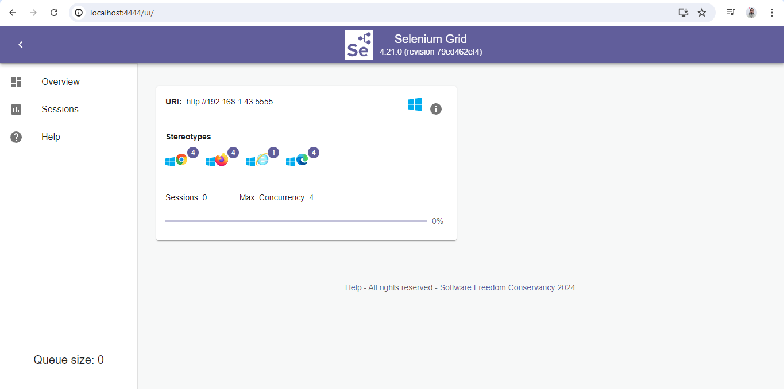
How to Perform Parallel Testing With Selenium Grid?
It is time for parallel testing using the Selenium Grid setup. The tests will be run in parallel on Chrome, Firefox, and Edge browsers.
Test Scenario:
- Navigate to the LambdaTest eCommerce Playground website.
- Search for a product using the search bar on the homepage.
- Check the page title of the search result page.
- Test Implementation:
The BaseTest class is created to manage WebDriver instances for running tests on a Selenium Grid. This class is available in the seleniumgriddemo package in the src/test folder.
1  2  3  4  5  6  7  8  9  10  11  12  13  14  15  16  17  18  19  20  21  22  23  24  25  26  27  28  29  30  31  32  33  34  35  36  37  38  39  40  41  42  43  44  45  46  47 | public class BaseTest {  private static final ThreadLocal<RemoteWebDriver> DRIVER = new ThreadLocal<>();  public RemoteWebDriver getDriver() {  return DRIVER.get();  }  private void setDriver(RemoteWebDriver remoteWebDriver) {  DRIVER.set(remoteWebDriver);  }  @Parameters("browser")  @BeforeClass(alwaysRun = true)  public void setup(String browser) {  try {  if (browser.equalsIgnoreCase("chrome")) {  ChromeOptions chromeOptions = new ChromeOptions();  chromeOptions.setCapability("se:name", "Test on Grid - Chrome");  setDriver(new RemoteWebDriver(new URL("http://localhost:4444"), chromeOptions));  } else if (browser.equalsIgnoreCase("firefox")) {  FirefoxOptions firefoxOptions = new FirefoxOptions();  firefoxOptions.setCapability("se:name", "Test on Grid - Firefox");  setDriver(new RemoteWebDriver(new URL("http://localhost:4444"), firefoxOptions));  } else if (browser.equalsIgnoreCase("edge")) {  EdgeOptions edgeOptions = new EdgeOptions();  edgeOptions.setCapability("se:name", "Test on Grid - Edge");  setDriver(new RemoteWebDriver(new URL("http://localhost:4444"), edgeOptions));  } else {  throw new Error("Browser configuration is not defined!!");  }  } catch (MalformedURLException e) {  throw new Error("Error setting up browsers in Grid");  }  getDriver().manage()  .timeouts()  .implicitlyWait(Duration.ofSeconds(20));  }  @AfterTest(alwaysRun = true)  public void tearDown() {  getDriver().quit();  }  What is Desired Capabilities?  Desired Capabilities is a class in Selenium used to set properties of browsers to perform cross browser testing of web applications. It stores the capabilities as key-value pairs and these capabilities are used to set browser properties like browser name, browser version, path of browser driver in the system, etc. to determine the behaviour of browser at run time.  public class IEtestforDesiredCapabilities {  public static void main(String[] args) {  //it is used to define IE capability  DesiredCapabilities capabilities = DesiredCapabilities.internetExplorer();  capabilities.setCapability(CapabilityType.BROWSER_NAME, "IE");  capabilities.setCapability(InternetExplorerDriver.  INTRODUCE_FLAKINESS_BY_IGNORING_SECURITY_DOMAINS,true);

Practice Codes:

1.
package selenium_PackTestNG;
import org.openqa.selenium.By;
import org.openqa.selenium.WebDriver;
import org.openqa.selenium.chrome.ChromeDriver;
public class CSSLocator {
public static void main(String[] args) throws
InterruptedException {

System.setProperty(&quot;webdriver.chrome.driver&quot;,&quot;C:\\Sel
enium\\chromedriver.exe&quot;);

WebDriver driver=new ChromeDriver();
driver.get(&quot;http://gmail.com&quot;);
//css=tag#id
Thread.sleep(5000);

//driver.findElement(By.cssSelector(&quot;input#identifier
Id&quot;)).sendKeys(&quot;abc@gmail.com&quot;);

//tag[name=value]
//driver.findElement(

By.cssSelector(&quot;input[name=identifier]&quot;)).sendKeys(&quot;a
bc@gmail.com&quot;);
//^ starts with
//driver.findElement(By.cssSelector(&quot;input[id^=&#39;id&#39;]&quot;
)).sendKeys(&quot;abc&quot;);
//$Ends with
//driver.findElement(By.cssSelector(&quot;input[id$=&#39;Id&#39;]&quot;
)).sendKeys(&quot;abc&quot;);

//Contains (*):
driver.findElement(By.cssSelector(&quot;input[id*=&#39;fier&#39;]&quot;
)).sendKeys(&quot;abc&quot;);

// css=tag.class
//driver.get(&quot;https://www.facebook.com/&quot;);
//driver.findElement(
By.cssSelector(&quot;input.inputtext
login_form_input_box&quot;)).sendKeys(&quot;abc@gmail.com&quot;);
//CSS in Selenium has an interesting feature
of allowing partial string matches using ^, $, and *.

}
}

2.
package selenium_PackTestNG;

import org.testng.annotations.DataProvider;
import org.testng.annotations.Test;

public class DataProviderExample11 {

@DataProvider
//This annotation helps in Data Driven testing
//The method name is getData()

public Object[][] hellomethod()
{
Object[][] data=new Object[3][2];
data[0][0]=&quot;sampleuser1&quot;;// 0 row 0 column [0][0]- value is sampleuser1
data[0][1]=&quot;abcdefg&quot;;// 0 row 1 column [0][1]- value is abcdefg

data[1][0]=&quot;testuser2&quot;; //1 row 0 column [1][0]- value is testuser2
data[1][1]=&quot;zsdeg&quot;; //1 row 1 column [1][1]- value is zsdeg

data[2][0]=&quot;getuser1&quot;; //2 row 0 column [2][0]- value is getuser1
data[2][1]=&quot;pass123&quot;; //2 row 1 column [2][1]- value is pass123
// Total rows 3(0-2) and number of columns 2(0-1)
return data;
}

@Test(dataProvider=&quot;hellomethod&quot;)// getData is the name of the met
public void setData(String username, String password)
{
System.out.println(&quot;you have provided username as::&quot;+username);
System.out.println(&quot;you have provided password as::&quot;+password);

}
}

3.
package selenium_PackTestNG;

import java.util.concurrent.TimeUnit;

import org.openqa.selenium.By;
import org.openqa.selenium.WebDriver;
import org.openqa.selenium.chrome.ChromeDriver;
import org.openqa.selenium.firefox.FirefoxDriver;
import org.testng.annotations.DataProvider;
import org.testng.annotations.Test;

public class DataProviderTest1 {
private static WebDriver driver;

@DataProvider
public Object[][] hellomethod()
{
Object[][] data=new Object[3][2];
data[0][0]=&quot;sampleuser1&quot;;// 0 row 0 column [0][0]- value is sampleuser1
data[0][1]=&quot;abcdefg&quot;;// 0 row 1 column [0][1]- value is abcdefg

data[1][0]=&quot;testuser2&quot;; //1 row 0 column [1][0]- value is testuser2
data[1][1]=&quot;zsdeg&quot;; //1 row 1 column [1][1]- value is zsdeg

data[2][0]=&quot;getuser1&quot;; //2 row 0 column [2][0]- value is getuser1
data[2][1]=&quot;pass123&quot;; //2 row 1 column [2][1]- value is pass123
// Total rows 3(0-2) and number of columns 2(0-1)
return data;
}

@Test(dataProvider=&quot;hellomethod&quot;)// getData is the name of the met

public void setData(String username, String password)
{

System.setProperty(&quot;webdriver.chrome.driver&quot;,&quot;C:\\Selenium\\chromedriver.exe&quot;);
driver=new ChromeDriver();

driver.manage().timeouts().implicitlyWait(10, TimeUnit.SECONDS);

driver.get(&quot;http://www.rediffmail.com&quot;);

driver.findElement(By.linkText(&quot;Sign in&quot;)).click();

driver.findElement(By.id(&quot;login1&quot;)).sendKeys(username);

driver.findElement(By.id(&quot;password&quot;)).sendKeys(password);
driver.findElement(By.name(&quot;proceed&quot;)).click();

// driver.findElement(By.xpath(&quot;.//*[@id=&#39;account_logout&#39;]/a&quot;)).click();

// driver.quit();
}
}
4.
package selenium_PackTestNG;

import java.util.concurrent.TimeUnit;

import org.openqa.selenium.By;
import org.openqa.selenium.WebDriver;

import org.openqa.selenium.chrome.ChromeDriver;
import org.openqa.selenium.firefox.FirefoxDriver;
import org.testng.Assert;
import org.testng.annotations.Test;

public class DefaultPageTest {
static String expectedText=&quot;Please identify yourself?&quot;;
@Test
public void LoginPageTest() throws InterruptedException {
System.setProperty(&quot;webdriver.chrome.driver&quot;,&quot;C:\\Selenium\\chromedriver.exe&quot;);
WebDriver driver=new ChromeDriver();
driver.get(&quot;http://demo.actitime.com&quot;);
Thread.sleep(5000);
String actualText = driver.findElement(By.id(&quot;headerContainer&quot;)).getText();
Assert.assertEquals(actualText, expectedText,&quot;Text ** is**not** present **in

**the** Webpage&quot;);
}
@Test
public void LoginPageloglist(){
System.setProperty(&quot;webdriver.chrome.driver&quot;,&quot;C:\\Selenium\\chromedriver.exe&quot;);
WebDriver driver=new ChromeDriver();

driver.get(&quot;http://demo.actitime.com&quot;);
driver.manage().timeouts().implicitlyWait(90, TimeUnit.SECONDS);
boolean status=
driver.findElement(By.id(&quot;logoContainer&quot;)).isDisplayed();

Assert.assertTrue(status,&quot;logo not found&quot;);

}

}
5. package selenium_PackTestNG;

import org.openqa.selenium.WebDriver;
import org.openqa.selenium.chrome.ChromeDriver;
import org.testng.annotations.Test;

public class Parallel_TestNG {
@Test
public void Testcase1() throws InterruptedException{
//System.setProp
System.setProperty(&quot;webdriver.chrome.driver&quot;,&quot;C:\\Selenium\\chromedriver.exe&quot;);
WebDriver driver=new ChromeDriver();
System.out.println(&quot;Mozilla Firefox method is running on Thread : &quot; +

Thread.currentThread().getId());

driver.get(&quot;http://gmail.com&quot;);
Thread.sleep(5000);

}
@Test
public void Testcase2() throws InterruptedException{
System.setProperty(&quot;webdriver.chrome.driver&quot;,&quot;C:\\Selenium\\chromedriver.exe&quot;);
WebDriver driver1=new ChromeDriver();
//System.setProperty(&quot;webdriver.gecko.driver&quot;,&quot;C:\\Selenium\\geckodriver.exe&quot;);
System.out.println(&quot;Chrome Method is running on Thread : &quot; +
Thread.currentThread().getId());

//WebDriver driver1=new FirefoxDriver();
driver1.get(&quot;http://www.rediffmail.com&quot;);
Thread.sleep(5000);

// driver1.close();

}
}
6.
package selenium_PackTestNG;
import org.testng.annotations.Test;
public class ProjAndCustomerTest1 {

@Test(groups=&quot;RegressionTest&quot;)
public void createCustomerTest() {
System.out.println(&quot;Create Project and

Customer&quot;);
}
@Test(groups=&quot;smokeTest&quot;)
public void modifyCustomerTest(){
System.out.println(&quot;Modify Customer&quot;);
}
@Test(groups=&quot;RegressionTest&quot;)
public void Customeradd(){
System.out.println(&quot;add new

Customer&quot;);
}
@Test(groups=&quot;RegressionTest&quot;)
public void RemoveCustomer(){
System.out.println(&quot;Remove some of the

old Customers&quot;);
}

}
7.
package selenium_PackTestNG;
import org.testng.annotations.Test;
public class ProjAndCustTest {
@Test(priority=1)
public void createCustomerTest(){
System.out.println(&quot;Create Customer&quot;);
}
@Test
public void modifyCustomerTest(){
System.out.println(&quot;Modify Customer&quot;);
}
@Test(dependsOnMethods=

{&quot;modifyCustomerTest&quot;})

public void atest(){
System.out.println(&quot;we are running a

test&quot;);

}
}
8.
package selenium_PackTestNG;

import org.testng.annotations.AfterGroups;
import org.testng.annotations.BeforeGroups;
import org.testng.annotations.Test;

public class ProjectAndCustomerTest2 {
@BeforeGroups(groups= {&quot;smokeTest&quot;,&quot;RegressionTest&quot;})
public void configBeforeGroup()
{
System.out.println(&quot;BeforeGroup&quot;);
}

@AfterGroups(groups= {&quot;smokeTest&quot;,&quot;RegressionTest&quot;})
public void configAfterGroup()
{
System.out.println(&quot;AfterGroup&quot;);
}
@Test(groups=&quot;smokeTest&quot;)
public void createCustomerTest() {
System.out.println(&quot;Create Project and Customer&quot;);
}
@Test(groups=&quot;RegressionTest&quot;)
public void modifyCustomerTest(){
System.out.println(&quot;Modify Customer&quot;);
}
}

9.
package selenium_PackTestNG;

import org.openqa.selenium.WebDriver;
import org.openqa.selenium.chrome.ChromeDriver;

import org.testng.annotations.Test;

import java.io.File;
import org.apache.commons.io.FileUtils;
import org.openqa.selenium.By;
import org.openqa.selenium.OutputType;
import org.openqa.selenium.TakesScreenshot;
import org.openqa.selenium.WebDriver;
import org.openqa.selenium.firefox.FirefoxDriver;
import org.openqa.selenium.support.events.EventFiringWebDriver;
import org.testng.ITestResult;
import org.testng.annotations.AfterMethod;
import org.testng.annotations.Test;
import org.testng.annotations.Test;

public class ScreenshotItest {
static WebDriver driver;

@Test
public static void captureScreenMethod() throws Exception{
System.setProperty(&quot;webdriver.chrome.driver&quot;,&quot;C:\\Selenium\\chromedriver.exe&quot;);

WebDriver driver=new ChromeDriver();

//driver.manage().window().maximize();
driver.get(&quot;https://www.rediffmail.com&quot;);
Thread.sleep(5000);
driver.findElement(By.linkText(&quot;Signin1&quot;)).click(); //Statement with incorrect Xpath

}
@AfterMethod //AfterMethod annotation - This method executes after every test

execution

public void screenShot(ITestResult result){
System.out.println(result.getStatus());
System.out.println(ITestResult.FAILURE);
//using ITestResult.FAILURE is equals to result.getStatus then it enters into if condition
if(ITestResult.FAILURE==result.getStatus()){
try{
// To create reference of TakesScreenshot
// TakesScreenshot screenshot=(TakesScreenshot)driver;
// Call method to capture screenshot
// src=screenshot.getScreenshotAs(OutputType.FILE);
// Copy files to specific location

EventFiringWebDriver edriver=new EventFiringWebDriver(driver);

File srcImg=edriver.getScreenshotAs(OutputType.FILE);
File destImg=new File(&quot;C:\\folder1\\new3.jpg&quot;);
FileUtils.copyFile(srcImg, destImg);
System.out.println(&quot;Successfully captured a screenshot&quot;);
}catch (Exception e){
System.out.println(&quot;Exception while taking screenshot &quot;+e.getMessage());
}
}
driver.quit();
}

}
10.

CSS stands for Cascading style sheets
It basically deals with styling like how elements are displayed on screen

Syntax:
XPATH: //Tag[@attribute=’value’]
CSS: Tag[attribute=’value’]
package selenium_PackTestNG;

import org.openqa.selenium.By;
import org.openqa.selenium.WebDriver;
import org.openqa.selenium.chrome.ChromeDriver;

public class CSSLocator {

public static void main(String[] args) throws InterruptedException {
System.setProperty("webdriver.chrome.driver","C:\\Selenium\\chromedriver.exe");
WebDriver driver=new ChromeDriver();
driver.get("http://gmail.com");
//css=tag#id
Thread.sleep(5000);
//driver.findElement(By.cssSelector("input#identifierId")).sendKeys("abc@gmail.com");
//tag[name=value]
//driver.findElement( By.cssSelector("input[name=identifier]")).sendKeys("abc@gmail.com");
//^ starts with
//driver.findElement(By.cssSelector("input[id^='id']")).sendKeys("abc");
//$Ends with
//driver.findElement(By.cssSelector("input[id$='Id']")).sendKeys("abc");

//Contains (*):
driver.findElement(By.cssSelector("input[id*='fier']")).sendKeys("abc");

// css=tag.class
//driver.get("https://www.facebook.com/");
//driver.findElement( By.cssSelector("input.inputtext login_form_input_box")).sendKeys("abc@gmail.com");

//CSS in Selenium has an interesting feature of allowing partial string matches using ^, $, and *.

}

}

Css Syntax:
// Note: Css locator is more faster than xpath locator.
driver.findElement(By.cssSelector(“<tagname>#<id value>”))

driver.findElement(By.cssSelector(“#<id value>”));
driver.findElement(By.cssSelector(“<tagname>[id=’<id value>’]”));
driver.findElement(By.cssSelector(“<tagname>.<class value>”));
driver.findElement(By.cssSelector(“.<class value>”));
driver.findElement(By.cssSelector(“<tagname>[class=’<class value>’]”));
driver.findElement(By.cssSelector(“<tagname>[href=’<href value>’]”));
driver.findElement(By.cssSelector("a[href='/favourites']"));
XPATH: //input[@name='username']
2
CSS: input[name='username']

XPath functions to uniquely identify the element.
- contains() [By text]
- starts-with() [By text]
- text()
By Text
- //h1[contains(text(),’ Log in to’)]
- //h1[contains(text(),’ in to Twitter’)]
By Text
- //h1[starts-with(text(),’Log in’)]
- //h1[starts-with(text(),’Log in to’)]
Text() method:s

- XPath allows you to navigate up the DOM when looking for elements to test or scrape.
- It’s compatible with old browsers (or it was at time of publishing—including older versions of Internet Explorer, which some corporations still use).
- Creating in XPath is more flexible than in CSS Selector.

- When you don’t know the name of an element, you can use contains to search for possible matches.

Advantages of Using CSS Selector
- It’s faster than XPath.
- It’s much easier to learn and implement.
- You have a high chance of finding your elements.
- It’s compatible with most browsers to date

XPath | //tagname[@attribute=’value’] | “//input[@name=’email’]”
CSS Selector | tagname[attribute=’value’] | “input[name=’email’]”
ID | No syntax | “id”
Name | No syntax | “name”
Class name | No syntax | “class-name”
Link text | No syntax | “link-text”
Partial link text | No syntax | “partial-text”
Tag name | No syntax | “tag-name

- Heavily used in development - JQuery is heavily reliant on CSS
- Can do almost everything an XPath expression can do
- Targeting elements in a shadow DOM - elements within a shadow DOM cannot be targeted with XPath

Cucumber:

Dependencies
- Cucumber Java(io.cucumber)
<!-- https://mvnrepository.com/artifact/io.cucumber/cucumber-java -->
<dependency>
<groupId>io.cucumber</groupId>
<artifactId>cucumber-java</artifactId>
<version>7.18.1</version>
</dependency>

- Junit
<dependency>
<groupId>junit</groupId>
<artifactId>junit</artifactId>
<version>3.8.1</version>
<scope>test</scope>
</dependency>

- Cucumber Junit
<!-- https://mvnrepository.com/artifact/io.cucumber/cucumber-junit -->
<dependency>
<groupId>io.cucumber</groupId>
<artifactId>cucumber-junit</artifactId>
<version>7.18.1</version>
<scope>test</scope>
</dependency>

- Selenium -Java
<!-- https://mvnrepository.com/artifact/org.seleniumhq.selenium/selenium-java -->
<dependency>
<groupId>org.seleniumhq.selenium</groupId>
<artifactId>selenium-java</artifactId>
<version>4.24.0</version>
</dependency>

Steps to create the project structure for Cucumber

Don’t forget to install plugin named as Cucumber for Java inside your IDE

# You have to create this file inside a package named as Feature and that package will be created inside your project
# and it will have same hierarchy as the src folder
# Type the feature file manually everyone

# After typing the feature file create a package inside java folder(the one which is residing in test folder) named
# as Runner and another package named as stepDefinition

# Inside Runner package you have to create a java file named as TestRunner and inside stepDefinition package
# you need to create a file named as LoginFunctionality

# for both the files you can get the code from selenium doc paste them

/// feature file is written using a simple english sentence
// Gherkin language is a language which is written in simple english language which helps to bridge the gap between
// the customer and testers.

// it makes easy to understand for the client that what testcases the tester has written and executed

Feature: Login Action1

Scenario : Successful Login with Valid Credentials1
Given User is on Home Page
When User Navigate to LogIn Page
And User enters username and password
Then Message displayed Login Successfully

package stepDefination_outline;

import org.junit.runner.RunWith;
import io.cucumber.junit.Cucumber;
import io.cucumber.junit.CucumberOptions;

@RunWith(Cucumber.class)
@CucumberOptions(features="C:\\Users\\geeta\\eclipse-workspace\\Cucumber_Selenium10\\src\\test\\resources",glue= {"stepDefination_outline"},
plugin = { "pretty", "html:C:\\Geetanjali\\Report\\test.html" },
monochrome=true)

@RunWith(Cucumber.class)
@CucumberOptions(features="C:\\Users\\geeta\\eclipse-workspace\\Cucumber_Selenium10\\src\\test\\resources",glue= {"stepDefination_outline"},
monochrome=true)

public class Runner10 {

Feature File (Login Feature):
^ - this is for beginning of the text
$- this is for the end of the text
Remember it is optional

Syntax: @When("^User Navigate to Login Page$")

Feature: Login Action1

Scenario : Successful Login with Valid Credentials1
Given User is on Home Page
When User Navigate to LogIn Page
And User enters username and password
Then Message displayed Login Successfully

Step Definition File
(LoginFunctionality)
package com.stepDefinition;

import io.cucumber.java.en.And;
import io.cucumber.java.en.Given;
import io.cucumber.java.en.Then;
import io.cucumber.java.en.When;
import org.junit.Test;

public class LoginFunctionality {

@Given("User is on Home Page")
public void User_is_on_Home_Page() {

}

@When("User Navigate to LogIn Page")
public void User_Navigate_to_LogIn_Page() {

}

@When("User enters username and password")
public void User_enters_username_and_password() {

}
@When(“User Cl
@Then("Message displayed Login Successfully")
public void Message_displayed_Login_Successfully() {

}

}

TDD - it stands for Test Driven Development , in this the test cases are written first and then the coding is done, for each module the approach which is followed here the code is written and then it is made to fail then the code is refracted(make changes) and then run the code again it might fail again in this scenario. The code is refracted again and again till the code/test cases passes. This is the approach which is followed by the development team and is close to the agile approach.

BDD - it stands for Behaviour Driven Development. It is derived from the TDD that is writing the test cases first and focuses on acceptance testing.

How can we involve client in the project from the beginning of the testing
- BY using the BDD framework because in this framework we try to maintain the documentation in simple english language.

What are the framework available which support BDD framework ?
- One of the framework is Cucumber which supports BDD approach.
Framework :
BDD Framework

Test Driven Development (TDD) is a software development practice that focuses on creating unit test cases before developing the actual code.
It is an iterative approach that combines programming, the creation of unit tests, and refactoring.

Cucumber framework is a framework which support BDD framework. Cucumber supports three kinds of file:
1- Feature file: which contains the documentation in a simple english language called as Gherkin. This Gherkin language or the feature file helps to collaborate with the customer or client because they can easily understand the documentation done in the Feature File.
2. Step Definition File: It contains the actual code in Selenium
3. Runner File creates a link between feature file and Step Definition File

Cucumber is an open-source software testing tool written in Ruby.
Cucumber is a testing tool that supports Behavior Driven Development (BDD)
A cucumber is a tool based on Behavior Driven Development (BDD) framework and agile software development methodology
which is used to write acceptance tests for the web application. which helps in bridging the gap between business and technical language it helps even non programmer to understand the test scripts
Cucumber supports many languages Java, JavaScript, PHP, Net, Python, Perl, etc.

Different teams in the project need a common language to express requirements.
Gherkin uses standard English and is used as a common Language for Clients, Developers, Testers, Business analysts and the Managerial team.

Cucumber+ +Cucumber for Java
Gherkin

1. Comments can be used only at the beginning of a new line in the feature file
2. Block comments cannot be used currently
3. Tabs or spaces can be used for indentation. It is recommended to have 2 spaces for indentation
4. The keyword used in Gherkhin language are as follows
1. Feature
2. Scenario/Scenarios and Scenario outline
3. Background
4. Example/Examples
5. Given, When, Then, And, But
6. Rule (as of Gherkin 6)
1. Feature File
2. Step Definition File
3. Test Runner file

2- Step Definition file: It contains the Selenium code which maps to the feature file documentation.

3- Runner file: It helps to link the Feature File and the Step Definition file.

Note: if we have not implemented the step definition file then JVM will throw error
throw new io.cucumber.java.PendingException();

TDD (Test Driven Development) and BDD (Behavior Driven Development) are fairly similar development approaches that both emphasize testing and collaboration, yet have major differences in focus and methodology. Simply put, in TDD, developers test first, then use the test results to guide their development, while in BDD, developers express the system behavior they want to create through Gherkin syntax, then code according to those Gherkin expressions.

BonVoyage Login and Logout using cucumber and Assert Class of Junit:
Feature File: ( Type manually)
Feature:Login Action1
Scenario:Successful Login With Valid Credentials1
Given User is on Home Page
When User Navigate to Login Page
And User enters username and password
Then Message displayed Login Successfully

Runner File Code:
package Runner;

import org.junit.runner.RunWith;
import io.cucumber.junit.Cucumber;
import io.cucumber.junit.CucumberOptions;

@RunWith(Cucumber.class)
@CucumberOptions(features="C://My Learning//CucumberProject//Features//Login.feature",glue= {"stepDefinition"},
monochrome=true)

public class TestRunner {
}

Step Defintion file Code:

package stepDefinition;

import io.cucumber.java.en.And;
import io.cucumber.java.en.Given;
import io.cucumber.java.en.Then;
import io.cucumber.java.en.When;
import org.junit.Assert;
import org.openqa.selenium.By;
import org.openqa.selenium.WebDriver;
import org.openqa.selenium.WebElement;
import org.openqa.selenium.chrome.ChromeDriver;

public class LoginFunctionality {
// @Given("User is on Home Page")
// public void User_is_on_Home_Page() {
// System.out.println("User is on Home Page");
// }
// @When("User_Navigate_to_LogIn_Page")
// public void User_Navigate_to_LogIn_Page() {
// System.out.println("User_Navigate_to_LogIn_Page");
// }
static WebDriver driver;

@Given("User is on Home Page")
public void user_is_on_home_page() {
driver = new ChromeDriver();

}
@When("User Navigate to Login Page")
public void user_navigate_to_login_page() {
driver.get("http://localhost:3001/");
driver.manage().window().maximize();

}
@And("User enters username and password")
public void user_enters_username_and_password() {
driver.findElement(By.xpath("//button[@tabindex='0']")).click();
driver.findElement(By.id("email")).sendKeys("abhi@gmail.com");
driver.findElement(By.id("password")).sendKeys("123456");
driver.findElement(By.xpath("//button[@type='submit']")).click();
}
@Then("Message displayed Login Successfully")
public void message_displayed_login_successfully() throws InterruptedException {
Thread.sleep(5000);
WebElement logoutButton = driver.findElement(By.xpath("//button[@tabindex='0']"));
// String expectedValue = "LOGOUT";

// Assert.assertEquals("Logout button is not displayed",expectedValue,logoutButton.getText());
boolean logoutbuttonDisplayed = logoutButton.isDisplayed();
Assert.assertTrue("Logout button is not displayed",logoutbuttonDisplayed);

logoutButton.click();
}

}

Parameterization/Data driven Testing- Running the same tests with multiple sets of data

Feature file:

Feature: Login Action for Scenario Outline
Scenario Outline is used for Data Driven Testing inside Cucumber
Scenario Outline: Successful Login with Valid Credentials
Given User is on Home Page
When User Navigate to LogIn Page
And User enters "<username>" and "<password>"
Then Message displayed Login Successfully
Examples:
| username | password |
| testuser_1 | Test@153 |
| testuser_2 | Test@153 |

Step Definition:

@When("^User enters \"(.*)\" and \"(.*)\"$")
public void user_enters_UserName_and_Password(String username, String password) throws Throwable {
driver.findElement(By.id("Email")).sendKeys(username);
driver.findElement(By.id("Password")).sendKeys(password);
driver.findElement(By.xpath("(//input[@type='submit'])[2]")).click();
Thread.sleep(3000);
//driver.findElement(By.id("login")).click();

Hooks Concept

Feature: Title of your feature
I want to use this template for my feature file
Scenario: Title of your scenario
Given I want to write a step with precondition
And some other precondition
When I complete action
And some other action
And yet another action
Then I validate the outcomes
And check more outcomes

Step Definition

package StepDefination_Hooks;

import io.cucumber.java.After;
import io.cucumber.java.Before;
import io.cucumber.java.en.And;
import io.cucumber.java.en.Given;
import io.cucumber.java.en.Then;
import io.cucumber.java.en.When;

public class Hooks12 {

@Before
public void beforeScenario(){
System.out.println("This will run before the every Scenario");

}
@Given("I want to write a step with precondition")
public void I_want_to_write_a_step_with_precondition() throws Throwable
{
System.out.println("I want to write a step with precondition");
}
@And("some_other_precondition")
public void some_other_precondition() {
System.out.println("I want to write a step with precondition");

}
@When("I_complete_action")
public void I_complete_action() {
System.out.println("I_complete_action");

}
@And("some_other_action")
public void some_other_action(){
System.out.println("some_other_action");
}
@And("yet_another_action")
public void yet_another_action(){
System.out.println("yet_another_action");
}
@Then("I_validate_the_outcomes")
public void I_validate_the_outcomes(){
System.out.println("I_validate_the_outcomes");
}
@And("check_more_outcomes")
public void check_more_outcomes(){
System.out.println("check_more_outcomes");

}

@After
public void afterScenario(){
System.out.println("This will run after the every Scenario");

}
}

Step Definition:

package StepDefination_Hooks;

import io.cucumber.java.After;
import io.cucumber.java.Before;
import io.cucumber.java.en.And;
import io.cucumber.java.en.Given;
import io.cucumber.java.en.Then;
import io.cucumber.java.en.When;

public class Hooks12 {

@Before
public void beforeScenario(){
System.out.println("This will run before the every Scenario");

}
@Given("I want to write a step with precondition")
public void I_want_to_write_a_step_with_precondition() throws Throwable
{
System.out.println("I want to write a step with precondition");
}
@And("some_other_precondition")
public void some_other_precondition() {
System.out.println("I want to write a step with precondition");

}
@When("I_complete_action")
public void I_complete_action() {
System.out.println("I_complete_action");

}
@And("some_other_action")
public void some_other_action(){
System.out.println("some_other_action");
}
@And("yet_another_action")
public void yet_another_action(){
System.out.println("yet_another_action");
}
@Then("I_validate_the_outcomes")
public void I_validate_the_outcomes(){
System.out.println("I_validate_the_outcomes");
}
@And("check_more_outcomes")
public void check_more_outcomes(){
System.out.println("check_more_outcomes");

}

@After
public void afterScenario(){
System.out.println("This will run after the every Scenario");

}
}

package StepDefination_Hooks;

import io.cucumber.java.After;
import io.cucumber.java.Before;
import io.cucumber.java.en.Given;
import io.cucumber.java.en.Then;
import io.cucumber.java.en.When;

public class Hooks_class {

@Before
public void beforeScenario(){
System.out.println("This will run before the every Scenario");
}

@After
public void afterScenario(){
System.out.println("This will run after the every Scenario");
}

@Before("@First")
public void beforeFirst(){
System.out.println("This will run only before the First Scenario");
}

@Before("@Second")
public void beforeSecond(){
System.out.println("This will run only before the Second Scenario");
}

@Before("@Third")
public void beforeThird(){
System.out.println("This will run only before the Third Scenario");
}

@After("@First")
public void afterFirst(){
System.out.println("This will run only after the First Scenario");
}

@After("@Second")
public void afterSecond(){
System.out.println("This will run only after the Second Scenario");
}

@After("@Third")
public void afterThird(){
System.out.println("This will run only after the Third Scenario");
}
}

Steps definition file stores the mapping between each step of the scenario defined in the feature file with a code of function to be executed.

Step definition file maps each step of the scenario defined in the feature file to code implementation. This code may be written in any Cucumber supported language like Java, Ruby etc
The test runner file should contain the path of the feature file and step definition file that we want to execute
TestRunner files are used to establish com between Feature and StepDefinition files.

The test runner file should contain the path of the feature file and step definition file that we want to execute

Test runner file must contain paths to feature file and step definition files to run

Feature: A feature would describe the current test script which has to be executed.
Scenario: Scenario describes the steps and expected outcome for a particular test case.
Scenario Outline: Same scenario can be executed for multiple sets of data using scenario outline. The data is provided by a tabular structure separated by (I I).
Given: It specifies the context of the text to be executed. By using datatables "Given", step can also be parameterized.
When: "When" specifies the test action that has to performed
Then: The expected outcome of the test can be represented by "Then"
Feature contains the The Title of the functionality which has to be tested along with the description of that feature
Scenario: A Scenario contains an optional Scenario Title.
Scenario also contains description of the scenario which is a collection of Steps.A feature can contain multiple Scenarios
Test Runner:

And: It provides the logical AND condition between any two statements. AND can be used in conjunction with GIVEN, WHEN and THEN statement.
Returns a logical AND condition between any two statements. AND can be used in conjunction with GIVEN, WHEN, and THEN statements.

But: It signifies logical OR condition between any two statements. OR can be used in conjunction with GIVEN, WHEN and THEN statement.

You can only have one set of Background steps per Feature or Rule. If you need different Background steps for different scenarios,
consider breaking up your set of scenarios into more Rules or more Features.

Background keyword is used to define some pre-conditions for all the scenarios.​​
Many times, we repeat the same ‘Given’ step in all the scenarios. Since ‘Given’ step is repeated in every scenario,​​ we can move such repeated steps to the background, by grouping them under a ‘Background’ section.​​
Background generally has the instruction on what to setup before each scenario runs. However, it gets executed after “Before” hook

We need some preconditions to run our scenario or a group of scenarios
sharing the same steps repeatedly. We can use background or hooks to set up these conditions

In Cucumber, tags are used to associate a test like smoke, regression etc. with a particular scenario.
Tagging not just specifically works with Scenarios, it also works with Features

Smoke testing; Sanity testing; Regression testing; Acceptance testing;

Cucumber uses tags to associate Sanity testing, Regression testing, Acceptance testing and other tests with specific scenarios.
tagging works for features as well as scenarios.

1. What are the tags included in Test Runner file?
The tags @RunWith and @CucumberOptions should be included.

Hooks are blocks of code that run before or after each scenario in the Cucumber execution cycle. This allows us to manage the code workflow better and helps to reduce code redundancy. Hooks can be defined anywhere in the project or step definition layers using the methods @Before and @After. Hooks can be helpful for tasks like opening and closing a browser, initializing test data, or capturing screenshots on test failure.

The two most common annotations are:

- @Before: This annotation indicates that the method should run before each test method (test case). It's often used for setup tasks, such as initializing the WebDriver or navigating to a specific URL before each test.
- @After: This annotation indicates that the method should run after each test method. It's used for cleanup tasks, such as closing the browser or capturing screenshots after each test.

Hooks provide a way to manage the test environment and ensure that it's properly set up and cleaned up before and after each scenario. This can help you maintain a consistent and reliable test execution process when using Selenium with Cucumber.

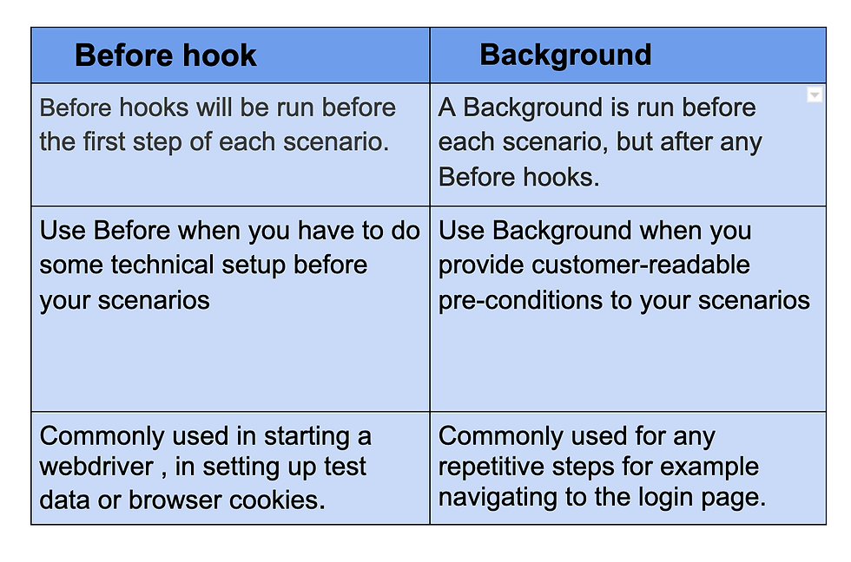

Background

Background:
Given User is on Home Page
When User Navigate to LogIn Page
And User enters username and password
Then Message displayed Login Successfully

Scenario: Print the text of First Product in Desktops
When User clicks on Computers
And User clicks on Desktop
Then User sorts by Price
Then User prints the text for first product displayed

Scenario: Print the text of First Product in Notebooks
When User clicks on Computers again
And User clicks on Notebooks
Then User sorts by Name
Then User prints the text for Second product displayed in Notebooks

TestRunner file:
package Runner;

import io.cucumber.junit.Cucumber;
import io.cucumber.junit.CucumberOptions;
import org.junit.runner.RunWith;

@RunWith(Cucumber.class)
@CucumberOptions(features="C:\\Users\\vibudi.prasad\\Downloads\\CucumberProject\\Features\\Hooks.feature",glue= {"stepDefinition"},
monochrome=true)
public class TestRunner {

}

→ Usage of Background with multiple scenarios and Hooks

StepDefinition file:
package stepDefinition;

import io.cucumber.java.After;
import io.cucumber.java.Before;
import io.cucumber.java.en.And;
import io.cucumber.java.en.Given;
import io.cucumber.java.en.Then;
import io.cucumber.java.en.When;
import org.junit.Assert;
import org.openqa.selenium.By;
import org.openqa.selenium.WebDriver;
import org.openqa.selenium.chrome.ChromeDriver;

import java.time.Duration;

public class LoginFunctionality {
static WebDriver driver;
String actual;
String expected;

@Before //initialize webdriver
public void beforeScenario(){
driver = new ChromeDriver();
driver.get("http://localhost:3001/");
driver.manage().window().maximize();
driver.manage().timeouts().implicitlyWait(Duration.ofSeconds(3));
}

//Background
@Given("User should navigate to Login page")
public void userShouldNavigateToLoginPage() {
System.out.println("Background begins here");
driver.findElement(By.xpath("//button[@type='button']")).click();
}

@When("User enters username")
public void userEntersUsername() {
driver.findElement(By.name("email")).sendKeys("siddhant.nanda@gmail.com");
}

@And("User enters password")
public void userEntersPassword() {
driver.findElement(By.id("password")).sendKeys("Prabhas123");
}

@Then("User clicks on SignIn")
public void userClicksOnSignIn() {
driver.findElement(By.xpath("//button[@type='submit']")).click();
}

//Scenario 1
@Given("User should navigate to HomePage")
public void userShouldNavigateToHomePage() {
System.out.println("User is redirected to HomePage after Login");
}

@When("Capture BonVoyage text from Logo")
public void captureBonVoyageTextFromLogo() {
actual = driver.findElement(By.linkText("BonVoyage")).getText();
}

@And("Enter expected text")
public void enterExpectedText() {
expected = "BonVoyage";
}

@Then("Assert the actual and expected BonVoyage")
public void assertTheActualAndExpectedBonVoyage() {
Assert.assertEquals(expected, actual);
System.out.println("Scenario 1 is completed");
}

//Scenario 2
@Given("User navigates to HomePage")
public void userNavigatesToHomePage() {
System.out.println("User is redirected to HomePage after Login");
}

@When("Capture username after login")
public void captureUsernameAfterLogin() {
actual = driver.findElement(By.xpath("//h5[text()='Hey,']")).getText();
}

@And("Enter expected username")
public void enterExpectedUsername() {
expected = "Hey, Siddhant Nanda";
}

@Then("Assert the actual and expected username")
public void assertTheActualAndExpectedUsername() {
Assert.assertEquals(expected, actual);
System.out.println("Scenario 2 is completed");
}

@After //close webdriver
public void afterScenario(){
driver.quit();
}
}

Feature file:
Feature: Title of your feature
Background: User enters his credentials to login
Given User should navigate to Login page
When User enters username
And User enters password
Then User clicks on SignIn

Scenario: Capture BonVoyage after login
Given User should navigate to HomePage
When Capture BonVoyage text from Logo
And Enter expected text
Then Assert the actual and expected BonVoyage

Scenario: Capture username after login
Given User navigates to HomePage
When Capture username after login
And Enter expected username
Then Assert the actual and expected username

StepDefination file: (using hooks and background for BonVoyage application)

package StepDefination;
import io.cucumber.java.After;
import io.cucumber.java.Before;
import io.cucumber.java.en.And;
import io.cucumber.java.en.Given;
import io.cucumber.java.en.Then;
import io.cucumber.java.en.When;
static WebDriver driver;
@Before
public void beforeScenario(){
driver = new FirefoxDriver();
}
@Given("^user is on home page$")
public void User_Is_On_Home_Page() {
driver.get("http://localhost:3003/");
driver.manage().window().maximize();
}
@When("^user navigate to login page$")
public void User_Navigate_To_Login_Page() throws InterruptedException {
Thread.sleep(1000);
driver.findElement(By.xpath("//button[@tabindex='0']")).click();
}
@And("^user enters username and password$")
public void User_Enters_Username_And_Password() {
driver.findElement(By.id("email")).clear();
driver.findElement(By.id("email")).sendKeys("manvisinghal123@gmail.com");
driver.findElement(By.id("password")).clear();
driver.findElement(By.id("password")).sendKeys("Manvi123");
driver.findElement(By.xpath("//button[@type='submit']")).click();
}

//first scenario
@When("^user checks for bonvoage text$")
public void User_Checks_For_Bonvoage_Text(){
WebElement ele = driver.findElement(By.xpath("//*[@id=\"root\"]/div[1]/div/header/div/a/p"));
String expectedText = ele.getText();
String ActualText = "BonVoyage";
System.out.println(expectedText);
Assert.assertEquals("expected and actual are equal" , expectedText, ActualText);
}
@Then("^user logout from application$")
public void User_Logout_From_Application(){
driver.findElement(By.xpath("//button[@tabindex='0']")).click();
System.out.println("first scenario completed");
}

//second Scenario
@When("^user for his name in the application$")
public void User_For_His_Name_In_Ihe_Application(){
WebElement ele = driver.findElement(By.xpath("//*[@id=\"root\"]/div[1]/div/header/div/div[2]/h5"));
String expectedText = ele.getText();
String ActualText = "Hey, Manvi Singhal";
System.out.println(expectedText);
Assert.assertEquals("Expected and actual are equal",expectedText, ActualText);
}
@Then("^user closes the application$")
public void User_Closes_The_Application(){
driver.findElement(By.xpath("//button[@tabindex='0']")).click();
System.out.println("second scenario completed");
}

@After
public void afterScenario(){
driver.quit();
}

import org.openqa.selenium.By;
import org.openqa.selenium.WebDriver;
import org.openqa.selenium.WebElement;
import org.openqa.selenium.firefox.FirefoxDriver;

import javax.sound.midi.Soundbank;

public class stepDefinations {
static WebDriver driver;
@Before
public void beforeScenario(){
driver = new FirefoxDriver();
}
@Given("^user is on home page$")
public void User_Is_On_Home_Page() {
driver.get("http://localhost:3003/");
driver.manage().window().maximize();
}
@When("^user navigate to login page$")
public void User_Navigate_To_Login_Page() throws InterruptedException {
Thread.sleep(1000);
driver.findElement(By.xpath("//button[@tabindex='0']")).click();
}
@And("^user enters username and password$")
public void User_Enters_Username_And_Password() {
driver.findElement(By.id("email")).clear();
driver.findElement(By.id("email")).sendKeys("manvisinghal123@gmail.com");
driver.findElement(By.id("password")).clear();
driver.findElement(By.id("password")).sendKeys("Manvi123");
driver.findElement(By.xpath("//button[@type='submit']")).click();
}

//first scenario
@When("^user checks for bonvoage text$")
public void User_Checks_For_Bonvoage_Text(){
WebElement ele = driver.findElement(By.xpath("//*[@id=\"root\"]/div[1]/div/header/div/a/p"));
String expectedText = ele.getText();
String ActualText = "BonVoyage";
System.out.println(expectedText);
Assert.assertEquals("expected and actual are equal" , expectedText, ActualText);
}
@Then("^user logout from application$")
public void User_Logout_From_Application(){
driver.findElement(By.xpath("//button[@tabindex='0']")).click();
System.out.println("first scenario completed");
}

//second Scenario
@When("^user for his name in the application$")
public void User_For_His_Name_In_Ihe_Application(){
WebElement ele = driver.findElement(By.xpath("//*[@id=\"root\"]/div[1]/div/header/div/div[2]/h5"));
String expectedText = ele.getText();
String ActualText = "Hey, Manvi Singhal";
System.out.println(expectedText);
Assert.assertEquals("Expected and actual are equal",expectedText, ActualText);
}
@Then("^user closes the application$")
public void User_Closes_The_Application(){
driver.findElement(By.xpath("//button[@tabindex='0']")).click();
System.out.println("second scenario completed");
}

@After
public void afterScenario(){
driver.quit();
}

}

Feature file
Feature: I want to use this template for my functionality
Background:
Given user is on home page
When user navigate to login page
And user enters username and password

Scenario: checking bonvoage Text
When user checks for bonvoage text
Then user logout from application

Scenario:
When user for his name in the application
Then user closes the application

@CucumberOptions(features="C:\\Users\\vibudi.prasad\\Downloads\\CucumberProject\\Features\\Hooks.feature",glue= {"stepDefinition"}, tags = "@Sanity", plugin = { "pretty", "html:target/cucumber-reports" }, monochrome=true)

plugin = { "pretty", "html:target/cucumber-reports" } → this will create an html file under target folder in Project Structure
- Now right-click on html file then
- Open in > Open in Associated application > Firefox

@Cucumber.Options( format={"json:target/Destination/cucumber.json"})

//When we specify json:target/Destination/cucumber.json - It will generate the JSON
report inside the Destination folder, in the target folder of the maven project.

Runner file of TestNG:

package TestRunner1;
import io.cucumber.testng.AbstractTestNGCucumberTests;
import io.cucumber.testng.CucumberOptions;
@CucumberOptions(tags = "", features = {"C:\\Users\\geetanjali.dev\\eclipse-workspace3\\Cucumber_TestNG\\src\\test\\resources\\FeaturesFolder\\LogintestNG.feature"}, glue = {"steps"},
plugin = {})
public class Runner1 extends AbstractTestNGCucumberTests {
}

Dependency to be added to run TestNG in Cucumber
- cucumber-java
- testng
- cucumber-testng
- selenium-java

For Cucumber Working With TestNG
Pom.xml file

<project xmlns="http://maven.apache.org/POM/4.0.0" xmlns:xsi="http://www.w3.org/2001/XMLSchema-instance"
xsi:schemaLocation="http://maven.apache.org/POM/4.0.0 http://maven.apache.org/xsd/maven-4.0.0.xsd">
<modelVersion>4.0.0</modelVersion>

<groupId>org.example</groupId>
<artifactId>CucumberUsingTestNG</artifactId>
<version>1.0-SNAPSHOT</version>
<packaging>jar</packaging>

<name>CucumberUsingTestNG</name>
<url>http://maven.apache.org</url>

<properties>
<project.build.sourceEncoding>UTF-8</project.build.sourceEncoding>
</properties>

<dependencies>
<dependency>
<groupId>junit</groupId>
<artifactId>junit</artifactId>
<version>3.8.1</version>
<scope>test</scope>
</dependency>

<!-- https://mvnrepository.com/artifact/io.cucumber/cucumber-java -->
<dependency>
<groupId>io.cucumber</groupId>
<artifactId>cucumber-java</artifactId>
<version>7.18.1</version>
</dependency>

<dependency>
<groupId>org.seleniumhq.selenium</groupId>
<artifactId>selenium-java</artifactId>
<version>4.24.0</version>
</dependency>

<!-- https://mvnrepository.com/artifact/io.cucumber/cucumber-testng -->
<dependency>
<groupId>io.cucumber</groupId>
<artifactId>cucumber-testng</artifactId>
<version>7.18.1</version>
</dependency>
<dependency>
<groupId>org.apache.logging.log4j</groupId>
<artifactId>log4j-slf4j-impl</artifactId>
<version>2.24.0</version>
<scope>test</scope>
</dependency>
<!-- https://mvnrepository.com/artifact/org.testng/testng -->
<dependency>
<groupId>org.testng</groupId>
<artifactId>testng</artifactId>
<version>7.10.2</version>
<scope>test</scope>
</dependency>

</dependencies>
</project>

Login.feature file
Feature:Login Action1

Scenario:Successful Login with Valid Credentials1
Given User is on Home Page
When User Navigate to LogIn Page
And User enters username and password
Then Message displayed Login Successfully

TestRunner file
package Runner;

import io.cucumber.testng.AbstractTestNGCucumberTests;
import io.cucumber.testng.CucumberOptions;
@CucumberOptions(features = {"C://Testing//Application//CucumberUsingTestNG//Features//Login.feature"}, glue = {"stepDefinition"})
public class TestRunner extends AbstractTestNGCucumberTests {
}

Step Definition File
package stepDefinition;

import io.cucumber.java.en.And;
import io.cucumber.java.en.Given;
import io.cucumber.java.en.Then;
import io.cucumber.java.en.When;

public class LoginFunctionality {
@Given("User is on Home Page")
public void User_is_on_Home_Page() {
System.out.println("User is on Home Page");
}

@When("User Navigate to LogIn Page")
public void User_Navigate_to_LogIn_Page() {
System.out.println("User Navigate to LogIn Page");
}

@And("User enters username and password")
public void User_enters_username_and_password() {
System.out.println("User enters username and password");
}

@Then("Message displayed Login Successfully")
public void Message_displayed_Login_Successfully() {
System.out.println("Message displayed Login Successfully");
}
}

Working With Multiple Elements on the webpage(Understanding findElements Method usecases):
package org.example;

import org.openqa.selenium.By;
import org.openqa.selenium.WebDriver;
import org.openqa.selenium.WebElement;
import org.openqa.selenium.chrome.ChromeDriver;
import org.openqa.selenium.edge.EdgeDriver;

import java.util.*;
public class LocatingMultipleWebElements {
public static void main(String[] args) throws InterruptedException{
WebDriver driver = new EdgeDriver();
driver.get("https://www.rediff.com/");
driver.manage().window().maximize();
driver.findElement(By.xpath("//a[text()='Sign in']")).click();

Thread.sleep(3000);
List<WebElement> elementList = driver.findElements(By.tagName("a"));
System.out.println(elementList.size());
// System.out.println(elementList.get(1).getText());
// System.out.println(elementList);
for(int i=0; i<elementList.size(); i++)
{
System.out.println(elementList.get(i).getText());
}

}
}

Working with Frames in Selenium

Switch to the frame by index
Index is one of the attributes for frame handling in Selenium through which we can switch to it.

Index of the iframe starts with ‘0’.

Suppose if there are 100 frames in page, we can switch to frame in Selenium by using index.

driver.switchTo().frame(0);

driver.switchTo().frame(1);

Switch to the frame by Name or ID
Name and ID are attributes for handling frames in Selenium through which we can switch to the iframe.

driver.switchTo().frame("iframe1");
driver.switchTo().frame("id of the element");

To move back to the parent frame, you can either use switchTo().parentFrame() or if you want to get back to the main (or most parent) frame, you can use switchTo().defaultContent();
driver.switchTo().parentFrame();
driver.switchTo().defaultContent();

package com.gl;

import org.openqa.selenium.By;
import org.openqa.selenium.WebDriver;
import org.openqa.selenium.chrome.ChromeDriver;

public class IFrameDemo {
public static void main(String[] args) throws InterruptedException {
WebDriver driver = new ChromeDriver();
driver.get("https://the-internet.herokuapp.com/nested_frames");

//Left
driver.switchTo().frame("frame-top");
driver.switchTo().frame("frame-left");
System.out.println(driver.findElement(By.tagName("body")).getText());

//Middle
driver.switchTo().parentFrame(); //frame-top
driver.switchTo().frame("frame-middle");
System.out.println(driver.findElement(By.tagName("body")).getText());
//Right
driver.switchTo().parentFrame(); //frame-top
driver.switchTo().frame("frame-right");
System.out.println(driver.findElement(By.tagName("body")).getText());

//Main Content
driver.switchTo().parentFrame(); //frame-top
driver.switchTo().defaultContent(); //frameSet

//Bottom
driver.switchTo().frame("frame-bottom");
System.out.println(driver.findElement(By.tagName("body")).getText());

}
}

Page Object Model(POM) It is design pattern used with Frameworks

Previously when we have written the code we have hard coded our input data/test data, locators in the code itself
But using Frameworks(Organizing our scripts) we can separate our input data/test data or locators away from the code.

Ways of separating the input data/test data from the code is
1.Data Provider in TestNG
2. Excel sheets
3. Database

Login button
Ok button
Locators : Object Repository- Collection of Locators
Seperating of locators from the code
That is maintaining an object Repository(collection of locators for the object) for the locators

What is the advantage of separating the locators from the code:
If there is any change in any of the objects in the new version then no need to search where we have used that object in the code. We can directly search in the object repository and change the locator for that object and this change will reflect throughout the code.

Page Object Model or POM is a design pattern or a framework that we use in Selenium using which one can create an object repository of the different web elements across the application. To simplify, in the Page Object Model framework, we create a class file for each web page. This class file consists of different web elements present on the web page
Here are some other things to know about the Page Object Model:
- Object repository: The POM creates an object repository that stores all web elements.

- Page classes: Each web page in the application has a corresponding page class in the automation script.

- Code reusability: The POM improves code reusability and test case maintenance.

- Lazy initialization: The POM is a lazy object locator that doesn't find web elements until they are used. This helps optimize performance.

- Best practices: Some best practices for using the POM include keeping page classes small and using meaningful names.

Page Object Model, also known as POM, is a design pattern in Selenium that creates an object repository for storing all web elements. It helps reduce code duplication and improves test case maintenance.
In Page Object Model, consider each web page of an application as a class file. Each class file will contain only corresponding web page elements. Using these elements, testers can perform operations on the website under test.
: This declares and initializes an object of the Login class
PageFactory.initElements(driver, Login.class):
This is a static method from pageFactory which
- Takes the webdriver driver to know which browser to interact with
- Looks into Login class for annotated webElements(using @FindBy)
- Initializes the webElements in the class
- Returns an instance of Login class with all elements initailized.

PageFactory

LoginPage class
package com.glo.desingPatternUsingPage;

import org.openqa.selenium.WebDriver;
import org.openqa.selenium.WebElement;
import org.openqa.selenium.support.FindBy;

public class LoginPage {
WebDriver webDriver;

@FindBy(id = "email")
WebElement EnterEmailId;
@FindBy(id = "password")
WebElement EnterPassword;
@FindBy(xpath = "//button[text()='Sign In']")
WebElement ClickOnSignIn;

// Constructor
public LoginPage(WebDriver webDriver){
this.webDriver = webDriver;
}

public void LogIn_Action(String uName, String pwd){
EnterEmailId.sendKeys(uName);
EnterPassword.sendKeys(pwd);
ClickOnSignIn.click();
}

}

HomePage class

package com.glo.desingPatternUsingPage;

import org.openqa.selenium.WebDriver;
import org.openqa.selenium.WebElement;
import org.openqa.selenium.support.FindBy;

public class HomePage {
WebDriver webDriver;

@FindBy(xpath = "//button[text()='Login / SignUp']")
WebElement LoginSignUp;

// Constructor
public HomePage(WebDriver webDriver){
this.webDriver = webDriver;
}

public void clickOnLoginSignUp(){
LoginSignUp.click();
}

}

DashboardPage Class

package com.glo.desingPatternUsingPage;

import org.openqa.selenium.WebDriver;
import org.openqa.selenium.chrome.ChromeDriver;
import org.openqa.selenium.support.PageFactory;

public class DashboardPage {
public static void main(String[] args) {
WebDriver webDriver = new ChromeDriver();
webDriver.get("http://localhost:3001");
webDriver.manage().window().maximize();

HomePage homePage = PageFactory.initElements(webDriver, HomePage.class);
homePage.clickOnLoginSignUp();

LoginPage loginPage = PageFactory.initElements(webDriver, LoginPage.class);
loginPage.LogIn_Action("chetankuhite@gmail.com","chetan@123");

}
}

JavaScriptExecuter

By leveraging the JavaScriptExecutor interface provided by Selenium WebDriver, JavaScript commands can be executed to perform scrolling actions like scrolling to a specific element, scrolling to the top or bottom of the page, or scrolling by a specific pixel amount.

- WebDriver driver= new FirefoxDriver(capabilities);

- // Launch Website
- driver.navigate().to(" ");

- //Scroll down the webpage by 4500 pixels
- JavascriptExecutor js = (JavascriptExecutor)driver;
- js.executeScript("scrollBy(0, 4500)");

Try this:
// identify element
WebElement l=driver.findElement(By.xpath("//*[text()='ABOUT US']"));
// Javascript executor
((JavascriptExecutor)driver).executeScript("arguments[0].scrollIntoView(true);", l);
Thread.sleep(800);

// identify element
WebElement n=driver.findElement(By.xpath("//*[text()='Contact']"));
// Javascript executor
((JavascriptExecutor)driver).executeScript("arguments[0].scrollIntoView
(true);", n);

WebDriver driver= new FirefoxDriver()

// Launch Website
driver.navigate().to("https://www.testandquiz.com/selenium/testing.html");

//Click on the Link Text using click() command
driver.findElement(By.linkText("This is a Link")).click();

//Go back to Home Page
driver.navigate().back();

//Go forward to Registration page
driver.navigate().forward();

// Go back to Home page
driver.navigate().to("https://www.testandquiz.com/selenium/testing.html");

//Refresh browser
driver.navigate().refresh();

//Closing browser
driver.close();
}
}

Selenium Browser Commands

- WebDriver driver= new FirefoxDriver(capabilities);

- // Launch Website
- driver.navigate().to("https://www.testandquiz.com/selenium/testing.html");

- //Click on the Link Text using click() command
- driver.findElement(By.linkText("This is a Link")).click();

- //Go back to Home Page
- driver.navigate().back();

- //Go forward to Registration page
- driver.navigate().forward();

- // Go back to Home page
- driver.navigate().to("https://www.testandquiz.com/selenium/testing.html");

- //Refresh browser
- driver.navigate().refresh();

- //Closing browser
- driver.close();
- }
- }

//LoginC

package com.glo.PageFactory;

import org.openqa.selenium.WebDriver;
import org.openqa.selenium.WebElement;
import org.openqa.selenium.interactions.Actions;
import org.openqa.selenium.support.FindBy;

public class LoginC {
WebDriver webDriver;

@FindBy(xpath = "//a[text()='Log in']")
WebElement LoginClick;

@FindBy(id = "Email")
WebElement EmailTextBox;

@FindBy(id = "Password")
WebElement PasswordTextBox;

@FindBy(xpath = "//input[@value='Log in']")
WebElement SubmitButton;

@FindBy(xpath = "//a[text()='Log out']")
WebElement LogoutButton;

public LoginC(WebDriver webDriver){
this.webDriver = webDriver;
}

public void clickOnLoginButton(){
LoginClick.click();
}

public void EnterEmailInEmailTextBox(String Email){
EmailTextBox.sendKeys(Email);
}

public void EnterPasswordInPasswordTextBox(String password){
PasswordTextBox.sendKeys(password);
}

public void ClickOnSubmitButton(){
SubmitButton.click();
}

public boolean LogoutButtonIsDisplay(){
return LogoutButton.isDisplayed();
}

public void NavigateBack(){
webDriver.navigate().back();
}

public void Navigate(){
webDriver.navigate().forward();
}
}

//LoginFun
package com.glo.StepDefination;

import com.glo.PageFactory.LoginC;
import io.cucumber.java.en.Given;
import io.cucumber.java.en.When;
import io.cucumber.java.en.And;
import io.cucumber.java.en.Then;
import org.openqa.selenium.WebDriver;
import org.openqa.selenium.chrome.ChromeDriver;
import org.openqa.selenium.interactions.Actions;
import org.openqa.selenium.support.PageFactory;

public class LoginFun {
private WebDriver webDriver = new ChromeDriver();
LoginC loginC = PageFactory.initElements(webDriver, LoginC.class);

@Given("User is on Home Page")
public void User_is_on_Home_Page(){
webDriver.get("https://demowebshop.tricentis.com/");
webDriver.manage().window().maximize();
}

@When("User Navigate to Login Page")
public void User_Navigate_to_Login_Page(){
loginC.clickOnLoginButton();
}

@And("^User enter \"(.*)\" and \"(.*)\"$")
public void User_enter_username_and_password(String username, String password){
loginC.EnterEmailInEmailTextBox(username);
loginC.EnterPasswordInPasswordTextBox(password);
}

@And("Click on Submit Button")
public void Click_on_Submit_Button() {
loginC.ClickOnSubmitButton();
}

@Then("Display the Logout Button")
public void Display_the_Logout_Button(){
System.out.println(loginC.LogoutButtonIsDisplay());
}
}

//Runner_c

package com.glo.Runner;

import io.cucumber.junit.Cucumber;
import io.cucumber.junit.CucumberOptions;
import org.junit.runner.RunWith;

@RunWith(Cucumber.class)
@CucumberOptions(features = "C:\\Users\\chetan.kuhite\\Desktop\\All Project files\\PageFactoryStepDefination\\src\\test\\resources\\Features\\loginD.feature",
glue = {"com/glo/StepDefination"})

public class Runner_C {

}

//loginD.feature
Feature: Login Action
Scenario Outline: Successfully Login
Given User is on Home Page
When User Navigate to Login Page
And User enter "<username>" and "<password>"
And Click on Submit Button
Then Display the Logout Button

Examples:
|username|password|
|chetankuhite@gmail.com|Chetan@123|
|manzmehadi1@gmail.com|Mehek@110|

import java.io.File;
import org.apache.commons.io.FileUtils;
import org.openqa.selenium.By;
import org.openqa.selenium.OutputType;
import org.openqa.selenium.TakesScreenshot;
import org.openqa.selenium.WebDriver;
import org.openqa.selenium.firefox.FirefoxDriver;
import org.openqa.selenium.support.events.EventFiringWebDriver;
import org.testng.ITestResult;
import org.testng.annotations.AfterMethod;
import org.testng.annotations.Test;
import org.testng.annotations.Test;

public class ScreenshotItest {
static WebDriver driver;

@Test
public static void captureScreenMethod() throws Exception{
//System.setProperty("webdriver.chrome.driver","C:\\Selenium\\chromedriver.exe");
WebDriver driver=new ChromeDriver();
//driver.manage().window().maximize();
driver.get("https://www.rediffmail.com");
Thread.sleep(5000);
driver.findElement(By.linkText("Signin1")).click(); //Statement with incorrect Xpath

}
@AfterMethod //AfterMethod annotation - This method executes after every test execution
public void screenShot(ITestResult result){
System.out.println(result.getStatus());
System.out.println(ITestResult.FAILURE);
//using ITestResult.FAILURE is equals to result.getStatus then it enters into if condition
if(ITestResult.FAILURE==result.getStatus()){
try{
// To create reference of TakesScreenshot
// TakesScreenshot screenshot=(TakesScreenshot)driver;
// Call method to capture screenshot
// src=screenshot.getScreenshotAs(OutputType.FILE);
// Copy files to specific location

EventFiringWebDriver edriver=new EventFiringWebDriver(driver);
File srcImg=edriver.getScreenshotAs(OutputType.FILE);
File destImg=new File("C:\\folder1\\new3.jpg");
FileUtils.copyFile(srcImg, destImg);
System.out.println("Successfully captured a screenshot");
}catch (Exception e){
System.out.println("Exception while taking screenshot "+e.getMessage());
}
}
driver.quit();
}

}

- onTestSuccess(): this method is invoked on the successful execution of any test.
- onTestFailure(): this method is invoked when a test fails to execute.
- onTestSkipped(): this method is invoked when we skip a test.
https://www.javadoc.io/doc/org.testng/testng/6.11/constant-values.html#org.testng.ITestResult.FAILURE

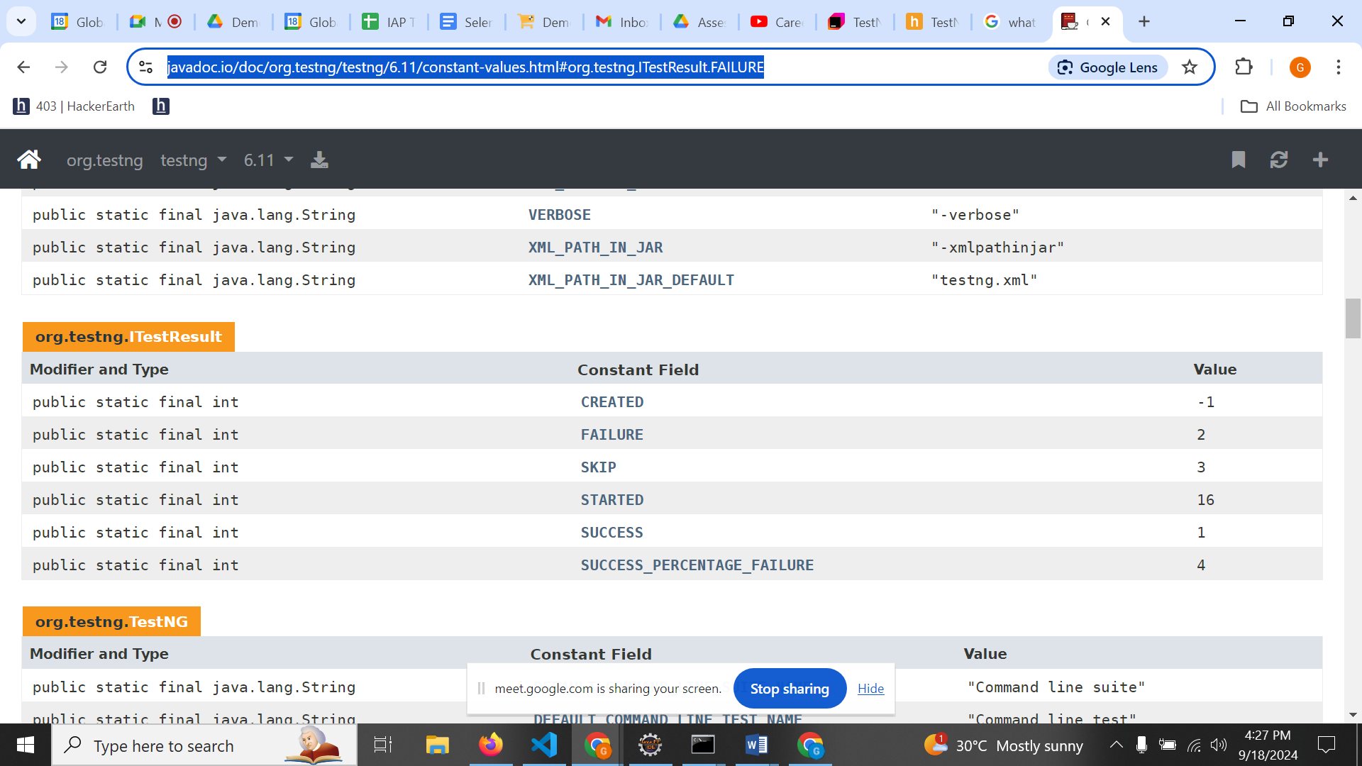

package com.gl;

import org.apache.commons.io.FileUtils;
import org.openqa.selenium.OutputType;
import org.openqa.selenium.TakesScreenshot;
import org.openqa.selenium.WebDriver;
import org.openqa.selenium.chrome.ChromeDriver;
import org.openqa.selenium.firefox.FirefoxDriver;
import org.openqa.selenium.support.events.EventFiringDecorator;

import java.io.File;
import java.io.IOException;

public class ScreenshotCapture {
public static void main(String[] args) throws IOException {
WebDriver driver = new ChromeDriver();
// Navigate to the testim website
driver.get("https://www.gmail.com/");
//Use TakesScreenshot method to capture screenshot
TakesScreenshot screenshot = (TakesScreenshot)driver;
//Saving the screenshot in desired location
File source = screenshot.getScreenshotAs(OutputType.FILE);
//Path to the location to save screenshot
FileUtils.copyFile(source, new File("./SeleniumScreenshots/Screen.png"));
System.out.println("Screenshot is captured");
driver.quit();
}

}

Preparation

Selenium IDE:
Difference between Assert and Verify

3 Types of commands are supported in Selenium IDE
Actions:
These commands directly interact with Page Elements:
Example click command

Accessors: These commands are used to store values
Example StoreTitle: Will store Title of Webpage

Assert Commands
Different Assert commands in Selenium IDE
- Assert
- Verify
- waitFor
JavaScriptExecutor:
Scroll commands
Working with Alerts using JavaScriptExecutor
To create an alert in JavaScript, you can use the alert() method. alert("Hello, world!"); When you run the above code, you'll see a pop-up alert box that says "Hello, world!

Handling Alerts(JavaScript/Alerts/confirmation popups), Pop Ups(Parent and child window) TestNG.XML(Parallel testing), test name:
XPath- Syntax: Parent, sibling, JavaScript Executor, Different kinds of Assertions,

TestNG : Every concept in TestNG
Annotations
Priority(0,1)
Depends on Methods
Groups
DataProvider- Different test cases with same data

- @BeforeSuite - The @BeforeSuite method in TestNG runs before the execution of all other test methods.
- @AfterSuite - The @AfterSuite method in TestNG runs after the execution of all other test methods.
- @BeforeTest - The @BeforeTest method in TestNG runs before the execution of all the test methods that are inside that folder.
- @AfterTest - The @AfterTest method in TestNG executes after the execution of all the test methods that are inside that folder.
- @BeforeClass - The @BeforeClass method in TestNG will run before the first method invokes of the current class.
- @AfterClass - The @AfterClass method in TestNG will execute after all the test methods of the current class execute.
- @BeforeMethod - The @BeforeMethod method in TestNG will execute before each test method.
- @AfterMethod - The @AfterMethod method in TestNG will run after each test method is executed.
- @BeforeGroups - The @BeforeGroups method in TestNG run before the test cases of that group execute. It executes just once.

- @AfterGroups - The @AfterGroups method in TestNG run after the test cases of that group execute. It executes only once.
https://www.tutorialspoint.com/selenium/selenium_multi_browser_testing.htm#:~:text=Create%20an%20XML%20which%20will,TestNG'%20Suite%20as%20shown%20below

java.lang.NoClassDefFoundError: gherkin/formatter/Formatter

Exception in thread "main" cucumber.runtime.CucumberException: No backends were found

import org.openqa.selenium.WebDriver;

public class BasePage {
protected WebDriver driver;

public BasePage(WebDriver driver) {
this.driver = driver;
}
}
Create a page class for the login page (LoginPage.java):
java
Copy code
import org.openqa.selenium.By;
import org.openqa.selenium.WebDriver;
import org.openqa.selenium.WebElement;

public class LoginPage extends BasePage {
private By emailField = By.id("Email");
private By passwordField = By.id("Password");
private By loginButton = By.cssSelector("input[value='Log in']");

public LoginPage(WebDriver driver) {
super(driver);
}

public void enterEmail(String email) {
WebElement emailInput = driver.findElement(emailField);
emailInput.clear();
emailInput.sendKeys(email);
}

public void enterPassword(String password) {
WebElement passwordInput = driver.findElement(passwordField);
passwordInput.clear();
passwordInput.sendKeys(password);
}

public void clickLoginButton() {
driver.findElement(loginButton).click();
}

// Add any other methods or assertions related to the login page here
}
Step 3: Create a Test Class

Now, create a test class that uses the page objects to perform the login test.

java
Copy code
import org.openqa.selenium.WebDriver;
import org.openqa.selenium.chrome.ChromeDriver;

public class LoginTest {
public static void main(String[] args) {
System.setProperty("webdriver.chrome.driver", "path/to/chromedriver.exe");
WebDriver driver = new ChromeDriver();
driver.manage().window().maximize();

try {
// Navigate to the login page
driver.get("https://demowebshop.tricentis.com/login");

// Create an instance of the LoginPage
LoginPage loginPage = new LoginPage(driver);

// Perform login using valid credentials
loginPage.enterEmail("your_email@example.com");
loginPage.enterPassword("your_password");
loginPage.clickLoginButton();

// Add assertions or validation steps here
// For example, check if the login was successful or if an error message is displayed.

} finally {
driver.quit();
}
}
}
Make sure to replace "path/to/chromedriver.exe" with the actual path to your ChromeDriver executable.

In this example, we've created a page object for the login page, which encapsulates all the page-specific elements and actions. The test class uses the page object to interact with the login page, making the code more maintainable and readable.

You can expand this framework by creating page classes for other pages of the application and organizing your tests accordingly.

What is the Page Object Model(POM)
Page Object Model or POM is a design pattern or a framework that we use in
Selenium using which one can create an object repository of the different web
elements across the application. To simplify, in the Page Object Model
framework, we create a class file for each web page. This class file consists of
different web elements present on the web page.
What are the advantages of the Page Object Model?
In the section above, we understood why a non-POM project could make our
project difficult to maintain, making it a huge advantage of the POM. Below are
some advantages of using the Page Object Model that highlights its efficiency:
Makes code maintainable- Since the test classes are separate from the classes
containing the web elements and the operation on them, updating the code is very
easy if any web element updates or a new one adds.
Makes code readable- User can easily read through the project and test scripts due
to a fine line between the test classes and the different web pages.
And, makes code reusable- If multiple test scripts use the same web elements, then
we need not write code to handle the web element in every test script. Placing it in a
separate page class makes it reusable by making it accessible by any test script.
package pages;
import org.openqa.selenium.By;
import org.openqa.selenium.WebDriver;
public class HomePage {
WebDriver driver;
//Constructor that will be automatically called as soon as the object
of the class is created
public HomePage(WebDriver driver) {
this.driver=driver;
}
//Locator for login button
By LoginBtn = By.id(&quot;login&quot;);
//Method to click login button
public void clickLogin() {
driver.findElement(LoginBtn).click();
}
}

package pages;

import org.openqa.selenium.By;
import org.openqa.selenium.WebDriver;
public class LoginPage {
WebDriver driver;
//Constructor that will be automatically called as soon as the object
of the class is created
public LoginPage(WebDriver driver) {
this.driver = driver;
}
//Locator for username field
By uName = By.id(&quot;userName&quot;);
//Locator for password field
By pswd = By.id(&quot;password&quot;);
//Locator for login button
By loginBtn = By.id(&quot;login&quot;);

//Method to enter username
public void enterUsername(String user) {
driver.findElement(uName).sendKeys(user);
}
//Method to enter password
public void enterPassword(String pass) {
driver.findElement(pswd).sendKeys(pass);
}
//Method to click on Login button
public void clickLogin() {
driver.findElement(loginBtn).click();
}
}
Dashboard.java

Once we log in, we will capture the page heading and locate the Logout
button to log out of the application.
package pages;
import org.openqa.selenium.By;
import org.openqa.selenium.WebDriver;
public class {
WebDriver driver;

//Constructor that will be automatically called as soon as the object
of the class is created
public Dashboard(WebDriver driver) {
this.driver=driver;
}
//Locators for the page title and the logout button
By heading = By.xpath(&quot;//div[@class=\&quot;main-header\&quot;]&quot;);
By logoutBtn = By.id(&quot;submit&quot;);
//Method to capture the page heading
public String getHeading() {
String head = driver.findElement(heading).getText();
return head;
}
//Method to click on Logout button
public void clickLogout() {
driver.findElement(logoutBtn).click();
}
}

package testCases;
import org.openqa.selenium.WebDriver;
import org.openqa.selenium.chrome.ChromeDriver;
import pages.Dashboard;
import pages.HomePage;
import pages.LoginPage;
public class Login_TC1 {
public static void main(String[] args) throws InterruptedException {
System.setProperty(&quot;webdriver.chrome.driver&quot;,

&quot;D:\\Selenium\\drivers\\chromedriver.exe&quot;);

WebDriver driver = new ChromeDriver();
driver.get(&quot;https://www.demoqa.com/books&quot;);
//Creating object of home page
HomePage home = new HomePage(driver);
//Creating object of Login page
LoginPage login = new LoginPage(driver);
//Creating object of Dashboard
Dashboard dashboard = new Dashboard(driver);
//Click on Login button
home.clickLogin();
//Enter username &amp; password
login.enterUsername(&quot;gunjankaushik&quot;);
login.enterPassword(&quot;Password@123&quot;);

//Click on login button
login.clickLogin();
Thread.sleep(3000);

//Capture the page heading and print on console
System.out.println(&quot;The page heading is --- &quot;

+dashboard.getHeading());

//Perform search and display search string on console
dashboard.enterSearchStr(&quot;java&quot;);
//CLick on Logout button
dashboard.clickLogout();

